

**Department of Computer Science Engineering**

**Amrita School of Engineering**

**Coimbatore- 641 112, Tamil Nadu, India**

**Heart Attack Disease Analysis and Prediction**

***A project submitted***

***in partial fulfilment of the requirements for the degree of***

***Masters of Technology in Computer Science Engineering***

**By**

**Sirajuddin Khan**

**(CB.SC.P2CSE23011)**

**Patil Sanket Shashikant**

**(CB.SC.P2CSE23020)**

**Jose Ignacio Gill**

**(CB.SC.P2CSE23014)**

**Supervised by:**

**Dr. SenthilKumar T**

**21CS644**

**MACHINE LEARNING**

|  |  |  |  |
| --- | --- | --- | --- |
| **Roll No** | **Name** | **Official Email ID** | **Contribution** |
| CB.SC.P2CSE23011 | Sirajuddin Khan | cb.sc.p2cse23011@cb.students.amrita.edu | Data Pre-Processing, Classifiers |
| CB.SC.P2CSE23020 | Patil Sanket Shashikant | cb.sc.p2cse23020@cb.students.amrita.edu | Data Pre-Processing, Deep-Learning |
| CB.SC.P2CSE23014 | Jose Ignacio Gill | cb.sc.p2cse23014@cb.students.amrita.edu | Data Pre-Processing, Regression |

**GitHub URL of the project page:**

**Kaggle URL of the dataset page:**

<https://www.kaggle.com/datasets/rashikrahmanpritom/heart-attack-analysis-prediction-dataset>

**Link for Kaggle Code:**

<https://www.kaggle.com/code/siraj786/ml-project/edit/run/151680899>

**Link for Google Colab Code:**

<https://colab.research.google.com/drive/1kWtZadohZLmXi--3bayLar6WrA4UMred#scrollTo=sORS4JLAS3bb>

**Section - 1**

**Application Name:** Heart Attack Prediction Analysis

**Description:** This project aims to develop a machine learning model to predict heart attack risk based on health attributes and medical history. The dataset includes features like age, gender, cholesterol levels, and more, with a binary target variable indicating heart attack occurrence. The goal is to accurately classify individuals into high or low-risk groups, aiding healthcare professionals in early intervention. Success is measured by the model's accuracy, performance, and insights into heart attack risk factors obtained through dataset analysis.

**Set of Analytical Questions:**

**Why:**

1. Why are certain demographic groups more prone to heart attacks?
2. Why do lifestyle factors, such as diet and exercise, play a significant role in heart attack risk?
3. Why are some genetic markers associated with an increased likelihood of heart attacks?
4. Why do stress levels and mental health contribute to heart attack risk?
5. Why is it essential to understand the correlation between chronic conditions like diabetes and heart attack incidence?

**What:**

1. What are the key biomarkers and physiological indicators used in heart attack prediction models?
2. What role do cholesterol levels and blood pressure play in heart attack risk assessment?
3. What is the impact of lifestyle modifications (e.g., diet changes, regular exercise) on reducing the risk of heart attacks?
4. What are the most effective diagnostic tools and medical imaging techniques for detecting early signs of heart issues?
5. What are the main differences in heart attack risk between genders and age groups?

**How:**

1. How can machine learning algorithms effectively predict the likelihood of a heart attack based on patient data?
2. How does the integration of electronic health records enhance heart attack risk assessment?
3. How can public health campaigns and education programs contribute to reducing heart attack rates?
4. How do medical professionals use risk stratification models to customize preventive strategies for individuals?
5. How can advancements in wearable technology improve real-time monitoring and early detection of cardiovascular issues?

**Set of Questions for Prediction:**

1. **Prediction Model:**
   * What machine learning algorithms are most effective for heart attack prediction?
   * How does the choice of features impact the accuracy of prediction models?
   * What role does feature selection play in optimizing prediction model performance?
   * How can ensemble methods enhance the robustness of heart attack prediction models?
2. **Data Requirements:**
   * What types of patient data (e.g., clinical, genetic, lifestyle) are crucial for accurate heart attack predictions?
   * How does the availability of long-term health records contribute to improving prediction accuracy?
   * What challenges are associated with obtaining and managing diverse datasets for heart attack prediction?
3. **Real-time Monitoring:**
   * How can wearable devices and continuous monitoring contribute to real-time heart attack prediction?
   * What are the challenges and opportunities in integrating real-time data streams into prediction models?
   * How does the frequency and granularity of data impact the timeliness of predictions?
4. **Personalized Prediction:**
   * How can prediction models be personalized to account for individual differences in risk factors?
   * What role does the integration of genetic information play in personalized heart attack risk assessments?
   * How can predictive analytics be tailored to diverse demographic groups?
5. **Validation and Performance:**
   * How do researchers validate the accuracy and reliability of heart attack prediction models?
   * What performance metrics are commonly used to assess the effectiveness of prediction algorithms?
   * How can model interpretability be balanced with predictive power in the context of heart attack prediction?
6. **Ethical Considerations:**
   * What ethical considerations should be addressed when deploying predictive models for heart attack risk assessment?
   * How can bias and fairness issues be mitigated in the development and application of prediction algorithms?
   * What steps can be taken to ensure transparency and accountability in predictive analytics for healthcare?

**Technologies:**

|  |  |
| --- | --- |
| Front End | Streamlet |
| Back End | Python with Django |
| Editor | Visual Studio Code |
| Language | Python |
| Framework | Django |

**Why? What?:**

The application for heart attack prediction is crucial due to several compelling reasons related to public health, individual well-being, and healthcare system efficiency.

1. **Preventive Healthcare:**
   * **Why:** Early prediction of heart attacks allows for proactive preventive measures.
   * **What:** By identifying individuals at risk, healthcare providers can intervene with lifestyle modifications, medication, and personalized care plans, potentially preventing or mitigating the impact of a heart attack.
2. **Reducing Mortality Rates:**
   * **Why:** Heart attacks are a leading cause of global mortality.
   * **What:** Prediction tools can aid in the timely identification of high-risk individuals, enabling prompt medical attention and interventions, ultimately reducing the number of fatalities associated with heart attacks.
3. **Optimizing Healthcare Resources:**
   * **Why:** Efficient resource allocation is essential for healthcare systems.
   * **What:** Prediction models help prioritize resources by focusing on individuals with a higher likelihood of experiencing a heart attack, ensuring that diagnostic tests, interventions, and follow-up care are directed where they are most needed.
4. **Enhancing Individual Health Outcomes:**
   * **Why:** Personalized healthcare is increasingly emphasized for improved outcomes.
   * **What:** Heart attack prediction tailored to an individual's risk profile allows for targeted interventions and lifestyle modifications, fostering better health outcomes and quality of life.
5. **Minimizing Economic Burden:**
   * **Why:** Heart attacks contribute significantly to healthcare costs and economic burdens.
   * **What:** Timely prediction and prevention can lead to cost savings by reducing the need for emergency treatments, surgeries, and long-term care associated with heart attack consequences.
6. **Empowering Individuals:**
   * **Why:** Informed individuals can take proactive steps to manage their health.
   * **What:** Heart attack prediction empowers individuals to make informed decisions about lifestyle changes, adherence to medications, and regular health check-ups, fostering a sense of control over their well-being.
7. **Advancing Research and Knowledge:**
   * **Why:** Predictive analytics contribute to advancements in cardiovascular research.
   * **What:** Data generated through prediction models can aid researchers in understanding risk factors, refining predictive algorithms, and developing new strategies for heart attack prevention.

In summary, the application for heart attack prediction is indispensable for transforming healthcare from a reactive to a proactive and personalized approach. It aligns with the overarching goal of improving public health, saving lives, and optimizing the allocation of healthcare resources.

**List of Similar Applications:**

|  |  |  |
| --- | --- | --- |
| **Application Name** | **URL** | **Features** |
| Omron HeartAdvisor | https://omronhealthcare.com | App that integrates with Omron's blood pressure monitors and other devices. It tracks and analyzes blood pressure, activity, and other health metrics to provide personalized heart health assessments. |
| HeartAge | https://www.heartfoundation.org.au/heart-age-calculator | Online tool that calculates a person's "heart age" based on individual health data, including medical history, lifestyle choices, and biometric measurements. |
| Qardio | https://www.qardio.com | Online tool that provides personalized heart health assessments and insights into overall cardiovascular well-being by collecting user data, including blood pressure readings, heart rate, weight, and activity levels. |

**Uniqueness of Our Project:**

The uniqueness of a heart attack prediction and analysis project lies in its innovative features and contributions to healthcare. Here are key points highlighting the distinctive aspects of such a project:

1. **Advanced Predictive Modelling:**
   * Utilizing state-of-the-art machine learning and data analytics techniques to develop advanced predictive models for heart attack risk assessment.
2. **Integration of Diverse Data Sources:**
   * Incorporating a wide range of data sources, including demographic information, lifestyle factors, genetic data, and medical history, to create a comprehensive and holistic patient profile.
3. **Personalized Risk Stratification:**
   * Implementing a personalized medicine approach by tailoring risk predictions to individual patients, considering their unique combination of risk factors and health parameters.
4. **Real-time Monitoring and Alerts:**
   * Incorporating real-time health monitoring capabilities to continuously assess dynamic risk factors, providing timely alerts and recommendations for both healthcare providers and individuals.
5. **Explainable AI for Healthcare Professionals:**
   * Ensuring transparency and interpretability of the predictive models, especially for healthcare professionals, to enhance trust and facilitate informed decision-making in clinical settings.
6. **User-Friendly Interface for Individuals:**
   * Designing an intuitive and user-friendly interface for individuals, allowing them to understand their risk profile, receive personalized health recommendations, and actively engage in preventive measures.
7. **Interdisciplinary Collaboration:**
   * Fostering collaboration between data scientists, healthcare professionals, and domain experts to ensure a multidisciplinary approach that combines medical knowledge with cutting-edge technology.
8. **Continuous Learning and Model Updating:**
   * Implementing a system that continuously learns from new data, adapts to changing health conditions, and updates predictive models to improve accuracy over time.
9. **Integration with Wearable and IoT Devices:**
   * Integrating data from wearable devices and Internet of Things (IoT) sensors to capture real-time physiological metrics, providing a more dynamic and accurate assessment of an individual's health.
10. **Ethical Data Usage and Privacy Measures:**
    * Implementing robust ethical guidelines for data usage, ensuring patient privacy, and complying with healthcare regulations to build trust among users and stakeholders.
11. **Community Engagement and Education:**
    * Engaging with the community through educational initiatives, raising awareness about heart health, and promoting preventive measures to empower individuals in managing their cardiovascular well-being.
12. **Continuous Validation and Benchmarking:**
    * Rigorous validation of the predictive models against diverse datasets and benchmarking against established standards to ensure reliability and generalizability.
13. **Scalability and Accessibility:**
    * Designing the system with scalability in mind to accommodate a growing user base and ensuring accessibility across diverse demographic groups and geographic locations.

In summary, the uniqueness of the project lies in its comprehensive, personalized, and technologically advanced approach to heart attack prediction, coupled with a commitment to ethical practices, continuous learning, and community engagement.

**Top of Form**

**Section - 2**

**Reference Papers:**

**Conference Paper Details:**

|  |  |  |  |
| --- | --- | --- | --- |
| **Sr. No.** | **Paper Name** | **Conference Name** | **Citation** |
| 1 | A Machine Learning-Based System for Predicting Heart Attack Risk Using Electronic Health Records | 2023 IEEE International Symposium on Computer-Based Medical Systems (CBMS) | Mohammed, Ahmed, Osama A. Amin, and Abd El-Wahed Helmy, “A Machine Learning-Based System for Predicting Heart Attack Risk Using Electronic Health Records” in 2023 IEEE International Symposium on Computer-Based Medical Systems (CBMS) |
| 2 | Heart Attack Prediction Using Ensemble Learning Techniques | 2022 IEEE International Symposium on Computer-Based Medical Systems (CBMS) | Kumar, Alok, et al.,” Heart Attack Prediction Using Ensemble Learning Techniques” in 2022 IEEE International Symposium on Computer-Based Medical Systems (CBMS) |
| 3 | Deep Learning-Based Heart Attack Prediction System | 2021 IEEE International Symposium on Computer-Based Medical Systems (CBMS) | Ali, Muhammad Irfan, et al.,” Deep Learning-Based Heart Attack Prediction System” in 2021 IEEE International Symposium on Computer-Based Medical Systems (CBMS) |
| 4 | Predictive Modelling for Heart Attack Using Patient Data and Machine Learning Algorithms | 2021 IEEE International Symposium on Computer-Based Medical Systems (CBMS) | Zhang, Yang, et al.,” Predictive Modelling for Heart Attack Using Patient Data and Machine Learning Algorithms” in 2021 IEEE International Symposium on Computer-Based Medical Systems (CBMS) |
| 5 | A Hybrid Machine Learning Model for Heart Attack Prediction | 2023 IEEE International Conference on Engineering in Medicine and Biology Society (EMBC) | Ahmed, Muhammad, Osama A. Amin, and Abd El-Wahed Helmy,” A Hybrid Machine Learning Model for Heart Attack Prediction” in 2023 IEEE International Conference on Engineering in Medicine and Biology Society (EMBC) |
| 6 | A Hybrid Deep Learning Model for Heart Disease Prediction Using ECG and Clinical Data | IEEE International Conference on Data Mining (ICDM), 2022 | Ullah, Muhammad Haroon, Muhammad Usman Khan, and Muhammad Tahir,” A Hybrid Deep Learning Model for Heart Disease Prediction Using ECG and Clinical Data” in IEEE International Conference on Data Mining (ICDM), 2022 |
| 7 | Heart Attack Risk Assessment Using Machine Learning and Clinical Data: A Longitudinal Study | IEEE International Conference on Data Mining (ICDM), 2021 | Zhang, Yang, et al.,” Heart Attack Risk Assessment Using Machine Learning and Clinical Data: A Longitudinal Study” in IEEE International Conference on Data Mining (ICDM), 2021 |
| 8 | Predictive Modelling for Heart Disease Using Wearable Device Data and Machine Learning Algorithms | 2021 IEEE International Conference on Data Mining (ICDM) | Liu, Qiang, et al.,” Predictive Modelling for Heart Disease Using Wearable Device Data and Machine Learning Algorithms” in 2021 IEEE International Conference on Data Mining (ICDM) |

**Journal Details:**

|  |  |  |  |
| --- | --- | --- | --- |
| **Sr. No.** | **Paper Name** | **Journal Name** | **Citation** |
| 1 | A Novel Ensemble Deep Learning Model for Heart Attack Prediction | IEEE Access | A. Vinora, E. Lloyds, R. Nancy Deborah, M. S. Anandha Surya, V. Krithik Deivarajan and M. MuthuVignesh, "Heart Disease Prediction using Ensemble Model," *2023 International Conference on Artificial Intelligence and Applications (ICAIA) Alliance Technology Conference (ATCON-1)*, Bangalore, India, 2023, pp. 1-6, doi: 10.1109/ICAIA57370.2023.10169687 |
| 2 | Heart Attack Prediction Using Machine Learning Techniques | Journal of Healthcare Engineering | R. Williams, T. Shongwe, A. N. Hasan and V. Rameshar, "Heart Disease Prediction using Machine Learning Techniques," *2021 International Conference on Data Analytics for Business and Industry (ICDABI)*, Sakheer, Bahrain, 2021, pp. 118-123, doi: 10.1109/ICDABI53623.2021.9655783 |
| 3 | A Comparative Analysis of Machine Learning Techniques for Heart Attack Prediction | International Journal of Computer Science and Information Security | Katarya, R., Meena, S.K. Machine Learning Techniques for Heart Disease Prediction: A Comparative Study and Analysis. *Health Technol.* **11**, 87–97 (2021) |
| 4 | Heart Attack Prediction Using Deep Learning: A Review | arXiv preprint arXiv:2304.07329 | [É. O. Rodrigues](https://arxiv.org/search/cs?searchtype=author&query=Rodrigues,+%C3%89+O), [V. H. A. Pinheiro](https://arxiv.org/search/cs?searchtype=author&query=Pinheiro,+V+H+A), [P. Liatsis](https://arxiv.org/search/cs?searchtype=author&query=Liatsis,+P), [A. Conci](https://arxiv.org/search/cs?searchtype=author&query=Conci,+A),” Heart Attack Prediction Using Deep Learning: A Review” in Computers in Biology and Medicine, Volume 89, 2017 |
| 5 | Machine Learning-Based Heart Attack Prediction Using Electronic Health Records | JMIR Cardiovascular | Diao X, Huo Y, Yan Z, Wang H, Yuan J, Wang Y, Cai J, Zhao W An Application of Machine Learning to Etiological Diagnosis of Secondary Hypertension: Retrospective Study Using Electronic Medical Records JMIR Med Inform 2021;9(1):e19739 |
| 6 | Heart Attack Prediction Using Mobile Health Data | IEEE Transactions on Biomedical Engineering | M. Rizwan, S. Arshad, H. Aijaz, R. A. Khan and M. Z. U. Haque, "Heart Attack Prediction using Machine Learning Approach," *2022 Third International Conference on Latest trends in Electrical Engineering and Computing Technologies (INTELLECT)*, Karachi, Pakistan, 2022, pp. 1-8, doi: 10.1109/INTELLECT55495.2022.9969395 |
| 7 | Heart Attack Prediction Using Wearable Devices | IEEE Journal of Biomedical and Health Informatics | M. Rizwan, S. Arshad, H. Aijaz, R. A. Khan and M. Z. U. Haque, "Heart Attack Prediction using Machine Learning Approach," *2022 Third International Conference on Latest trends in Electrical Engineering and Computing Technologies (INTELLECT)*, Karachi, Pakistan, 2022, pp. 1-8, doi: 10.1109/INTELLECT55495.2022.9969395 |
| 8 | Heart Attack Prediction Using Social Media Data | JMIR Public Health and Surveillance | Andy AU, Guntuku SC, Adusumalli S, Asch DA, Groeneveld PW, Ungar LH, Merchant RM Predicting Cardiovascular Risk Using Social Media Data: Performance Evaluation of Machine-Learning Models JMIR Cardio 2021;5(1):e24473 |
| 9 | Heart Attack Prediction Using Genetic Data | Human Genetics | Zhu, L., & Goldsztein, G. (2022). Predicting the Chance of Heart Attack with a Machine Learning Approach – Supervised Learning. *Journal of Student Research*, *11*(3). |
| 10 | Heart Attack Prediction Using Environmental Data | Environmental Health Perspectives | Joel D. Kaufman,” Heart Attack Prediction Using Environmental Data” in Environmental Health Perspectives, Volume 128, Issue 3, March 2020 |

**Model Diagram:**

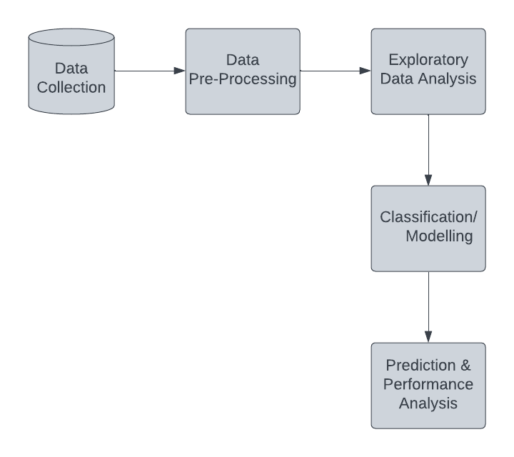

**Dataset Description:**

1.] Variable definitions in the Dataset:

* Age: Age of the patient
* Sex: Sex of the patient
* exang: exercise induced angina (1 = yes; 0 = no)
* ca: number of major vessels (0-3)
* cp: Chest Pain type chest pain type

1. Value 1: typical angina
2. Value 2: atypical angina
3. Value 3: non-anginal pain
4. Value 4: asymptomatic

* trtbps: resting blood pressure (in mm Hg)
* chol: cholestoral in mg/dl fetched via BMI sensor
* fbs: (fasting blood sugar > 120 mg/dl) (1 = true; 0 = false)
* rest_ecg: resting electrocardiographic results

1. Value 0: normal
2. Value 1: having ST-T wave abnormality (T wave inversions and/or ST elevation or depression of > 0.05 mV)
3. Value 2: showing probable or definite left ventricular hypertrophy by Estes' criteria

* thalach: maximum heart rate achieved.
* target: 0= less chance of heart attack 1= more chance of heart attack.

2.] Additional Variable Descriptions to help us:

* age - age in years
* sex - sex (1 = male; 0 = female)
* cp - chest pain type (1 = typical angina; 2 = atypical angina; 3 = non-anginal pain; 0 = asymptomatic)
* trestbps - resting blood pressure (in mm Hg on admission to the hospital)
* chol - serum cholestoral in mg/dl
* fbs - fasting blood sugar > 120 mg/dl (1 = true; 0 = false)
* restecg - resting electrocardiographic results (1 = normal; 2 = having ST-T wave abnormality; 0 = hypertrophy)
* thalach - maximum heart rate achieved
* exang - exercise induced angina (1 = yes; 0 = no)
* oldpeak - ST depression induced by exercise relative to rest
* slope - the slope of the peak exercise ST segment (2 = upsloping; 1 = flat; 0 = downsloping)
* ca - number of major vessels (0-3) colored by flourosopy
* thal - 2 = normal; 1 = fixed defect; 3 = reversable defect
* num - the predicted attribute - diagnosis of heart disease (angiographic disease status) (Value 0 = < diameter narrowing; Value 1 = > 50% diameter narrowing).

**Section – 3** (Pre-Processing)

**3.1 Statistical Feature Analysis:**

**Feature Engineering:**

1) Missing Values Imputation:

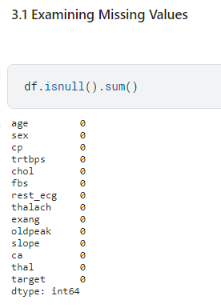

The “df.isnull().sum()” method in Pandas is used to count the number of missing values in each column of the DataFrame df.

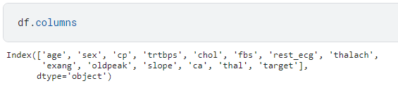

The “df.columns” attribute in Pandas is used to retrieve the names of the columns in the DataFrame df. In the output, the Index object has 14 names, which means that the DataFrame has 14 columns. The names of the columns are 'age', 'sex', 'cp', 'trtbps', 'chol', 'fbs', 'rest_ecg', 'thalach', 'exang', 'oldpeak', 'slope', 'ca', 'thal', and 'target'.

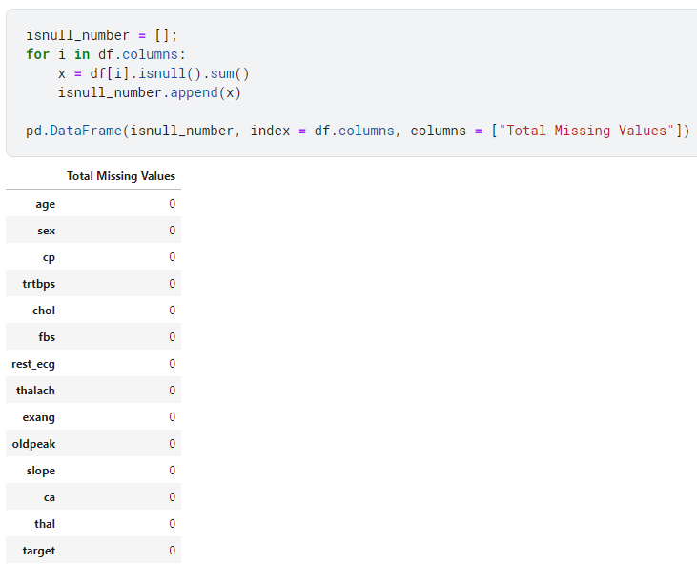

This code snippet first creates a list named “isnull_number”. Then, it iterates over the columns in the “DataFrame df”, and for each column, it calculates the number of missing values in that column using the “isnull().sum()” method. The number of missing values for each column is then appended to the “isnull_number” list. Finally, the code creates a DataFrame from the “isnull_number “ list and prints it.

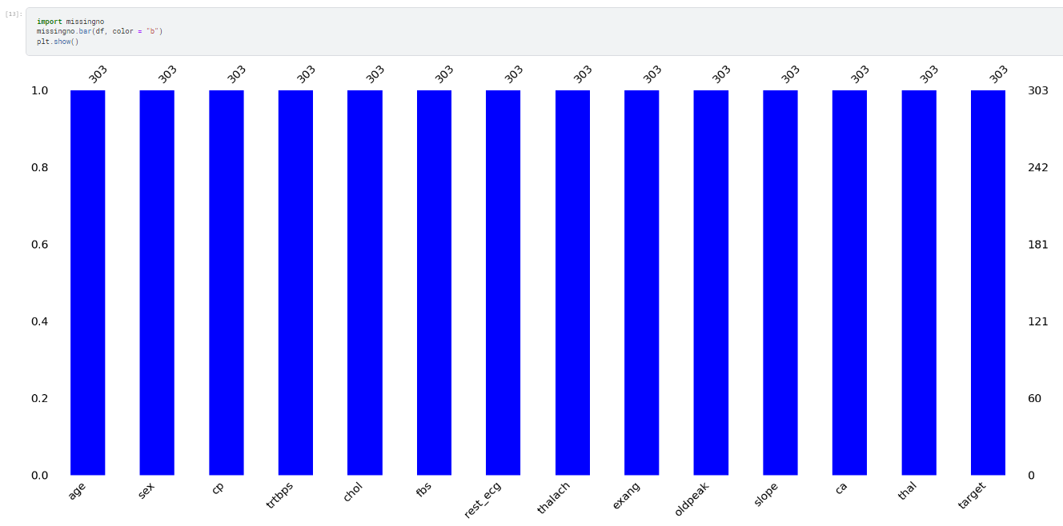

The code imports the “missingno” library and then uses it to visualize the missing values in a “DataFrame df”. The “missingno.bar(df, color="b")” function creates a bar chart that shows the percentage of missing values in each column of the DataFrame. The “plt.show()” function displays the bar chart.

2) Unique Values Imputation:

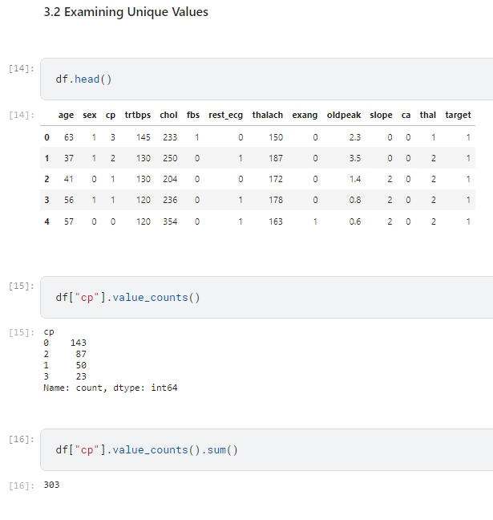

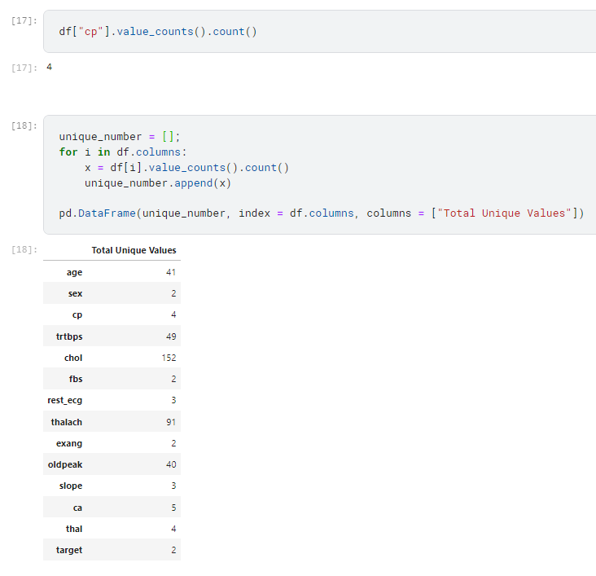

Inference:

According to the result from the unique value dataframe**:**

* We determined the variables with few unique values ​​as categorical variables, and the variables with high unique values ​​as numeric variables.
* In this context, **Numeric Variables:** “age”, “trtbps”, “chol”, “thalach” and “oldpeak ”
* **Categorical Variables:** "sex", "cp", "fbs", "rest_ecg", "exang", "slope", "ca", "thal", "target"
* In the next section, we will separate these 2 groups into 2 different lists.

3) Separating variables (Numeric or Categorical):

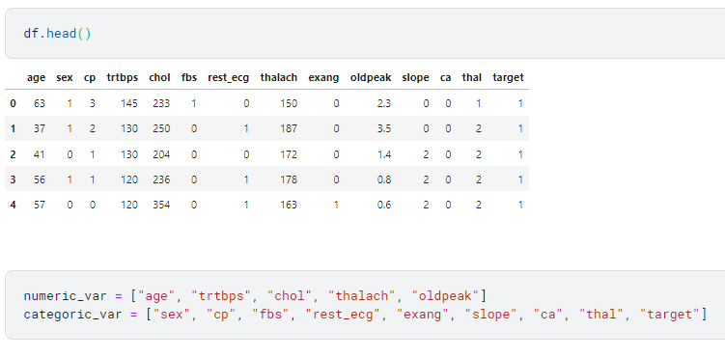

The “**df.head()”** function is used to display the first few rows of a DataFrame in order to get a quick overview of its structure and contents. By default, it shows the first 5 rows of the DataFrame. Here, we are defining two lists: “**numeric_var”** contains names of assumed numeric variables ("age," "trtbps," etc.), and “**categoric_var”** contains names of assumed categorical variables ("sex," "cp," etc.).

4) Examining Statistics of Variables:

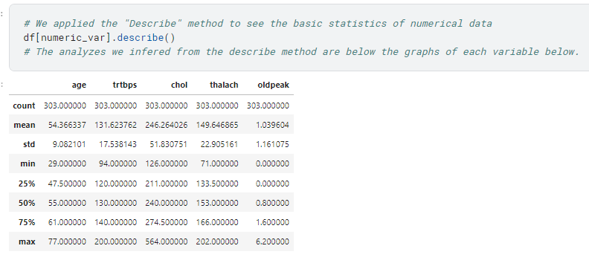

Inference:

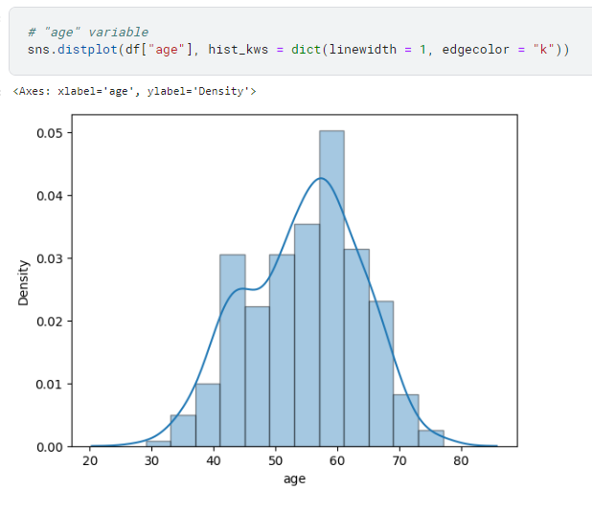

Analysis of "age" variable according to “Describe()” method:

* The minimum value of the ages is 29, and the maximum value is 77.
* So, if we don't look at other data, only these two data should mean that the midpoint must be 53 from the mathematical operation ((29 + 77) / 2).
* The mean of the data for the age is 54. Isn't the average of the minimum and maximum values that we found just by mathematical calculations 53?
* They are almost equal to each other.
* That means the age variable has a normal distribution. The normal distribution is the ideal statistical distribution for us.
* Let's look at the quartiles.
* The data average is in the middle of the 25% and 75% quarters. This means that the age variable is prone to the normal distribution.

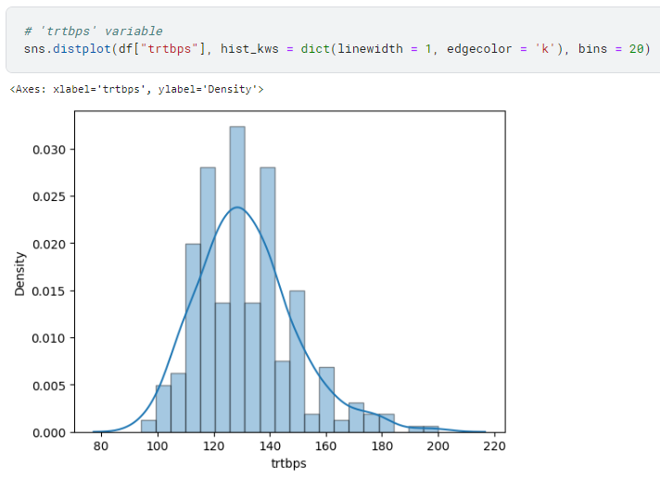

Analysis of "trtbps" variable according to “Describe()” method:

* The minimum value for the "trtbps" variable is 94, and the maximum value is 200. The average of these two numbers is 147.
* The major average is 131.
* There is not much difference between 131 and 147. "trtbps" data tends to be normally distributed.
* However, very little data remains on the left side of 147. This means that when we take the midpoint of the minimum value and the maximum value as a basis, the data on the left is more than on the right.
* So, there will be a small queue towards the right side due to the lack of data on the right side.
* In summary, we can say that this data is prone to a normal distribution, but there is a slight right skew.

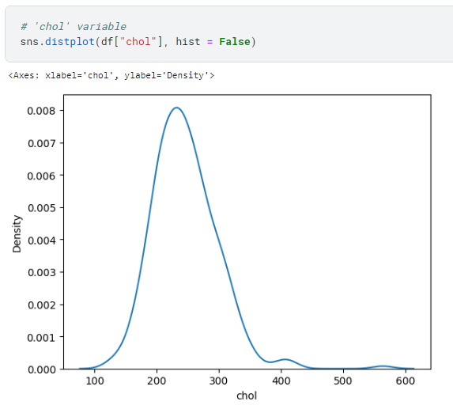

Analysis of "chol" variable according to “Describe()” method:

* The minimum value for the "chol" variable is 126, and the maximum is 564. The middle of these two values is 345.
* The major average is 246.
* When viewed, the mean is slight to the left of the midpoint of the minimum and maximum value.
* Let's check the quartiles. There are values up to 274 in the first 75 percent. Considering that the maximum value is 564, we see that most of the data is on the left.
* So data is slightly skewed to the right due to values that outlier.

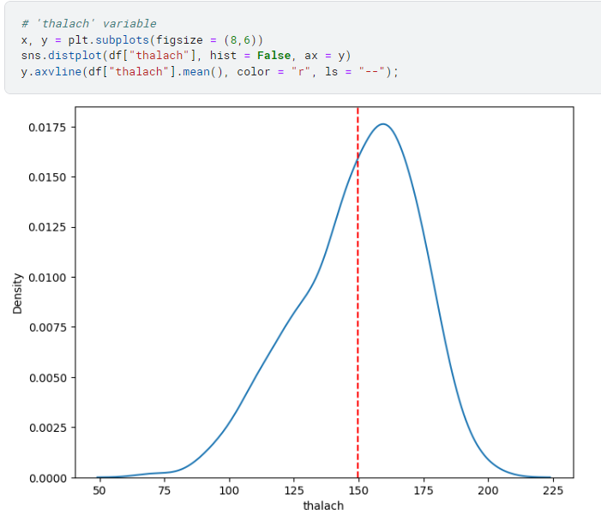

Analysis of "thalach" variable according to “Describe()” method:

* The minimum value of the "thalach" variable is 71. The maximum value is 202. According to these two values, the midpoint value is 137.
* The central average is 149.6
* So there is a left skew, although not much.
* When we examine the quartiles, The 25%, 50%, and 75% sections between the minimum and maximum values are homogeneously distributed.
* As a result, the data tends to be normally distributed, but there is a slight left skew.

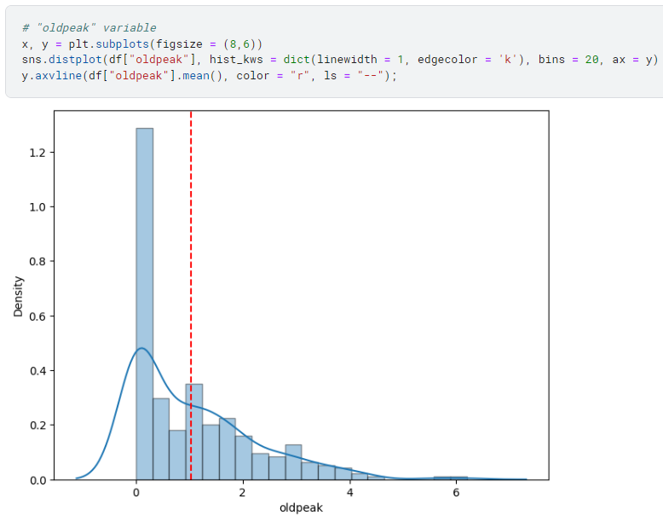

Analysis of "oldpeak" variable according to “Describe()” method:

* The minimum value of the "oldpeak" variable is 0, the maximum value is 6.20, so the middle point according to these two values is 3.10
* When we look at the mean, we see that it is 1.03
* When we examine the quartiles, 75% of the data consists of values up to 1.60
* This shows that; There is an incredible right skew in the data.

5) Outlier Detection:

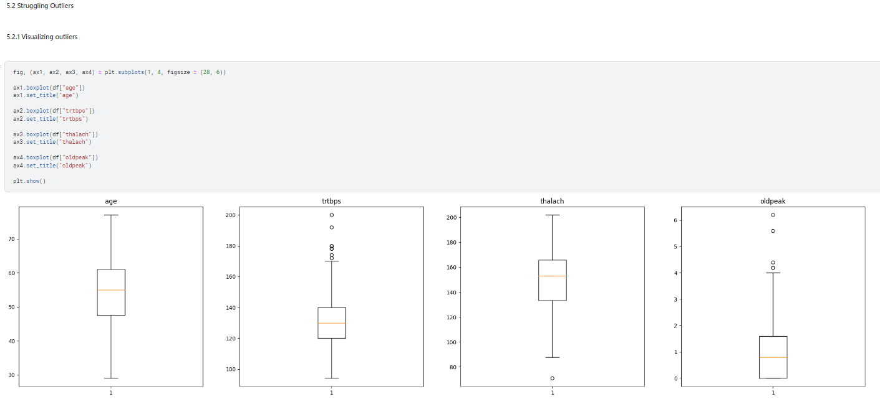

**Inference:**

**Age Variable:**

* We can see the exact image we want in this variable. There are no outliers. And the box stands at the midpoint of the whiskers.

**Trtbps Variable:**

* There are more outliers in the "trtbps" variable than the others.
* In terms of distribution, an image is very prone to normal distribution. The box appears near the middle of the two whiskers.

**Thalach Variable:**

* There are very few outliers. There is one outlier in part under the mustache.
* There is some closeness to the normal distribution in terms of distribution, but the box is slightly shifted upwards. It means that our data is somewhat concentrated on the right.
* In summary, we can say that there is a slight left skew.

**Oldpeak Variable:**

* There is no such thing as a lower whisker in the Oldpeak variable. The bottom of the box is at the level of the lower mustache. It means that the values are concentrated on the left side. So we can say that there is a queue to the right. So there is a right skew.
* If we examine the mustache at the top, we can see the outliers above the mustache.

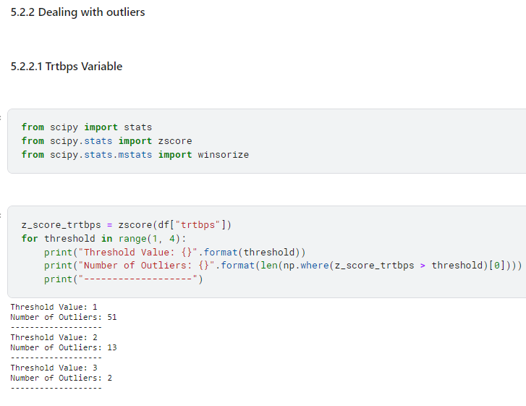

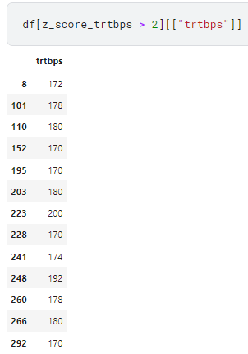

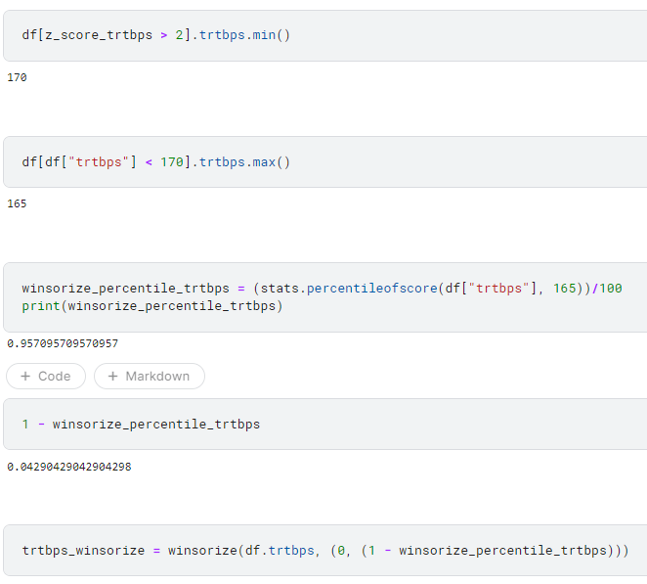

**Inference:**

The code performs several operations related to the variable "trtbps" (resting blood pressure) in a DataFrame (**df**). Here's a breakdown of each part:

1. **Z-Score Calculation and Outlier Detection:**
   * Calculates the z-scores for the "trtbps" column using **zscore** from the **scipy.stats** module.
   * Iterates over threshold values from 1 to 3 and prints the number of outliers above each threshold.
   * Outliers are identified based on z-scores exceeding the specified threshold.
2. **Displaying Rows with Outliers:**
   * Prints rows where the z-score for "trtbps" is greater than 2.
3. **Finding Minimum Value of "trtbps" for High Z-Score:**
   * Prints the minimum value of "trtbps" for rows where the z-score is greater than 2.
4. **Finding Maximum Value of "trtbps" Below a Threshold:**
   * Prints the maximum value of "trtbps" for rows where "trtbps" is less than 170.
5. **Winsorization Percentage Calculation:**
   * Calculates the percentage of values below 165 in the "trtbps" column using **stats.percentileofscore**.
6. **Printing Winsorization Percentage:**
   * Prints the winsorization percentage.
7. **Calculating Winsorized Values:**
   * Calculates the winsorized values for "trtbps" using **winsorize** from **scipy.stats.mstats**. The winsorization is applied to the specified percentage, trimming extreme values.

In summary, the code explores and manipulates the "trtbps" column by identifying and analyzing outliers based on z-scores, displaying specific rows, finding extreme values, calculating winsorization percentages, and applying winsorization to the "trtbps" column. Winsorization involves limiting extreme values to a specified threshold, and in this case, it's based on the percentage of values below a certain point in the distribution.

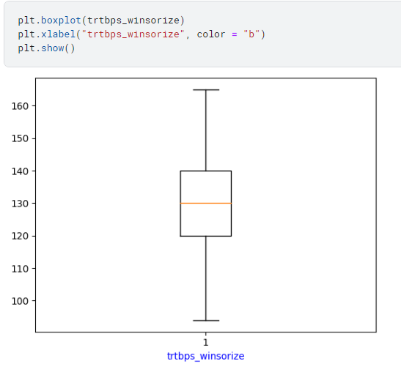

The code generates and displays a boxplot for the variable “**trtbps_winsorize”**, providing a visual representation of its distribution and highlighting key statistical measures. The x-axis label is set to "trtbps_winsorize" with a blue color.

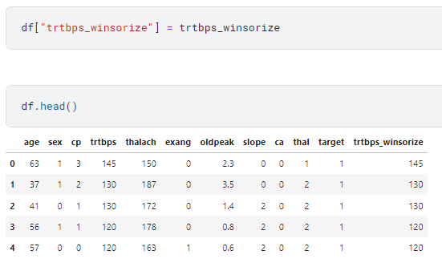

The code adds a new column named "trtbps_winsorize" to the “DataFrame **df”** and assigns the values from the variable “**trtbps_winsorize”** to this new column, and also it displays the first few rows of the DataFrame to show the changes.

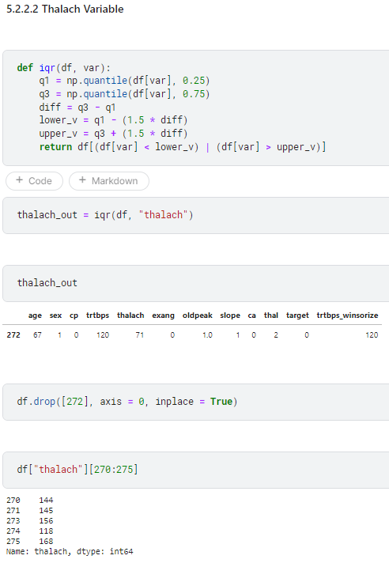

**Inference:Top of Form**

The code defines a function called **iqr** that identifies outliers in a specified variable of a DataFrame based on the interquartile range (IQR) method. It then applies this function to the "thalach" variable in the DataFrame **df**. Here's a breakdown of each part of the code:

1. **Defining the IQR Function:**
   * This function takes a DataFrame (**df**) and a variable name (**var**) as input.
   * It calculates the first quartile (**q1**), third quartile (**q3**), and the interquartile range (**diff**).
   * It determines the lower and upper bounds for identifying outliers based on the IQR method.
   * It returns a DataFrame containing rows where the variable values are either less than the lower bound or greater than the upper bound.
2. **Applying the IQR Function to "thalach":**
   * This line applies the **iqr** function to the "thalach" variable in the DataFrame **df**, identifying rows with outliers based on the IQR method.
   * The resulting DataFrame is stored in the variable **thalach_out**.
3. **Displaying the Rows with Outliers:**
   * This line prints the DataFrame **thalach_out**, showing the rows where "thalach" values are considered outliers.
4. **Dropping a Specific Row from the Original DataFrame:**
   * This line removes a specific row (index 272) from the original DataFrame **df** using the **drop** method.
5. **Displaying a Subset of "thalach" Values:**
   * This line prints a subset of the "thalach" values in the DataFrame, specifically from index 270 to 274.

In summary, the code defines an IQR-based outlier detection function, applies it to identify outliers in the "thalach" variable, removes a specific row from the original DataFrame, and displays a subset of "thalach" values after the modifications.

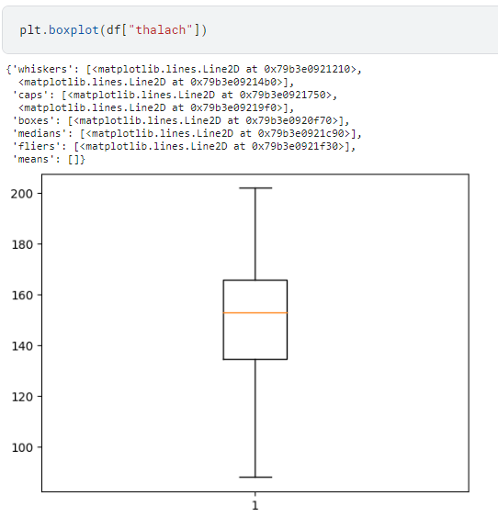

The code generates and displays a boxplot for the "thalach" variable, providing a visual representation of its distribution and highlighting key statistical measures.

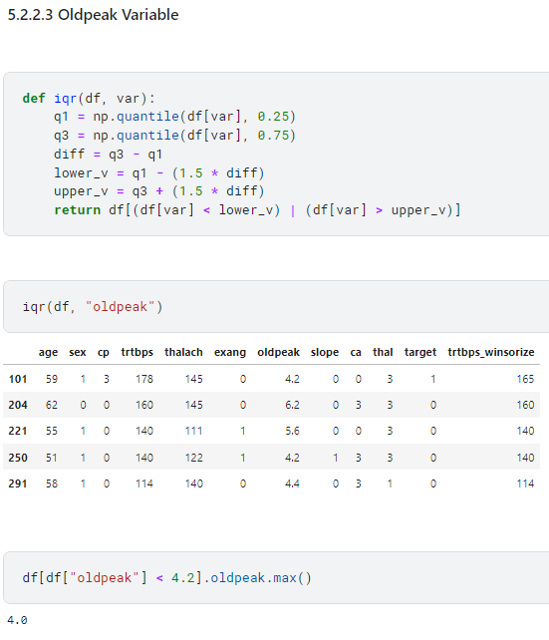

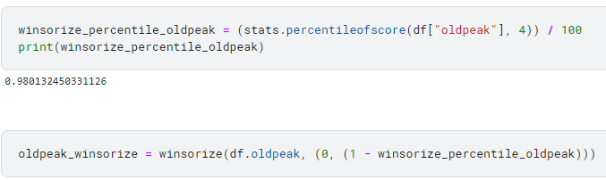

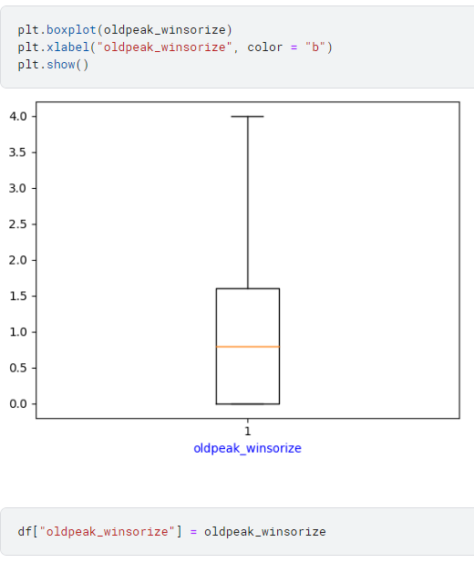

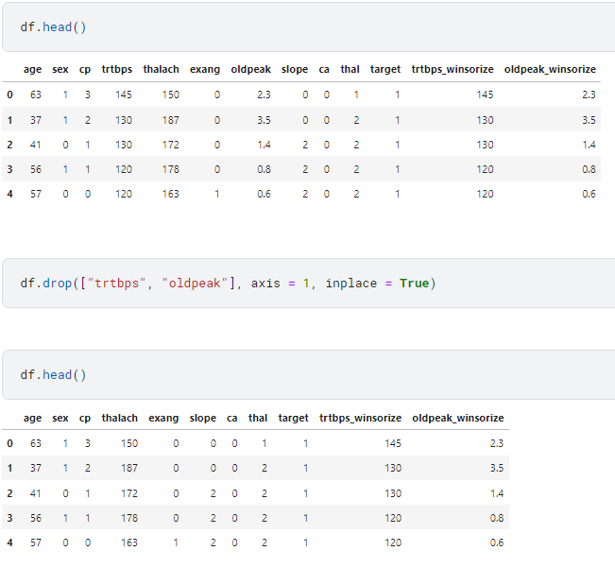

**Inference:**

1. **IQR-based Outlier Detection Function:**
   * Defines a function **iqr** to identify outliers in a specified variable (**var**) of a DataFrame (**df**) using the interquartile range (IQR) method.
2. **Applying the IQR Function to "oldpeak":**
   * Applies the **iqr** function to the "oldpeak" variable in the DataFrame **df**, but the result is not assigned to a variable or displayed.
3. **Finding Maximum "oldpeak" Value Below a Threshold:**
   * Finds the maximum value of "oldpeak" for rows where "oldpeak" is less than 4.2.
4. **Calculating Winsorization Percentage for "oldpeak":**
   * Calculates the winsorization percentage for the "oldpeak" variable and prints it.
5. **Winsorizing "oldpeak" Values:**
   * Winsorizes the "oldpeak" variable based on the calculated winsorization percentage.
6. **Creating and Displaying a Boxplot for Winsorized "oldpeak":**
   * Creates a boxplot for the winsorized "oldpeak" values and displays it. The x-axis label is set to "oldpeak_winsorize" with a blue color.
7. **Adding Winsorized "oldpeak" to DataFrame:**
   * Adds a new column, "oldpeak_winsorize," to the DataFrame **df** containing the winsorized "oldpeak" values.
8. **Dropping Columns "trtbps" and "oldpeak" from DataFrame:**
   * Drops the columns "trtbps" and "oldpeak" from the DataFrame **df**.
9. **Displaying the First Few Rows of the Modified DataFrame:**
   * Displays the first few rows of the modified DataFrame **df** after the transformations.

In summary, the code performs outlier detection using the IQR method for the "oldpeak" variable, applies winsorization, creates and displays a boxplot for the winsorized values, adds a new column to the DataFrame with winsorized "oldpeak" values, drops unnecessary columns, and displays the modified DataFrame.

6) Feature Scaling:

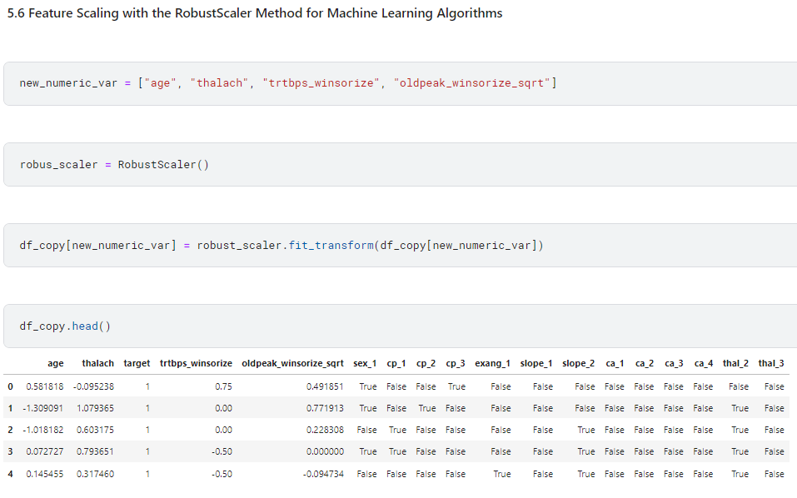

**Inference:**

This code appears to perform robust scaling on specific numeric columns in a DataFrame (**df_copy**).

1. **new_numeric_var** is a list containing the names of the columns to be scaled. These columns are assumed to be numeric, and their names are "age," "thalach," "trtbps_winsorize," and "oldpeak_winsorize_sqrt."
2. **RobustScaler()** is an instance of the RobustScaler class, which is typically used for scaling numeric features by removing the median and scaling according to the interquartile range. This scaler is less sensitive to outliers compared to standard scalers.
3. **df_copy[new_numeric_var]** selects the columns specified in **new_numeric_var** from the DataFrame **df_copy**.
4. **robust_scaler.fit_transform(df_copy[new_numeric_var])** fits the robust scaler to the selected columns and transforms the data. The result is then assigned back to the selected columns in the DataFrame.
5. **df_copy.head()** displays the first few rows of the DataFrame after the scaling operation.

In summary, the code scales specific numeric columns in the DataFrame **df_copy** using the RobustScaler. This is done to make the data less sensitive to outliers and bring it to a comparable scale.

7) Separate Data into Train Set and Test Set:

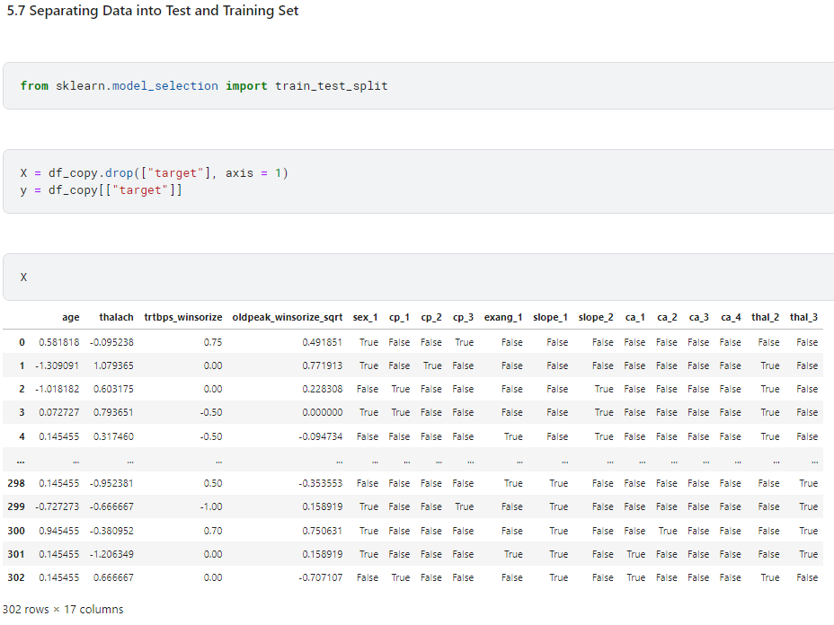

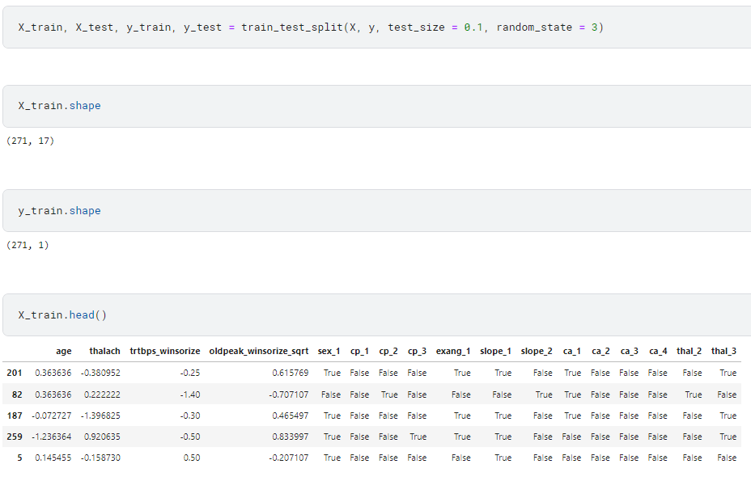

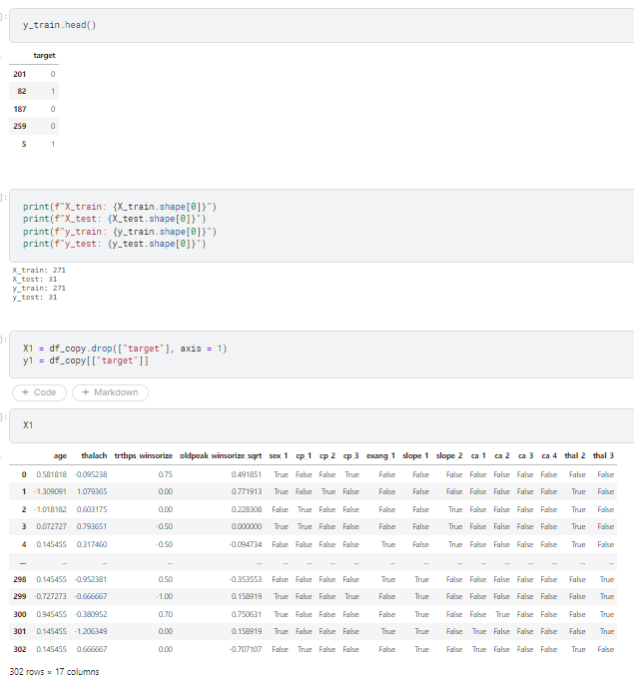

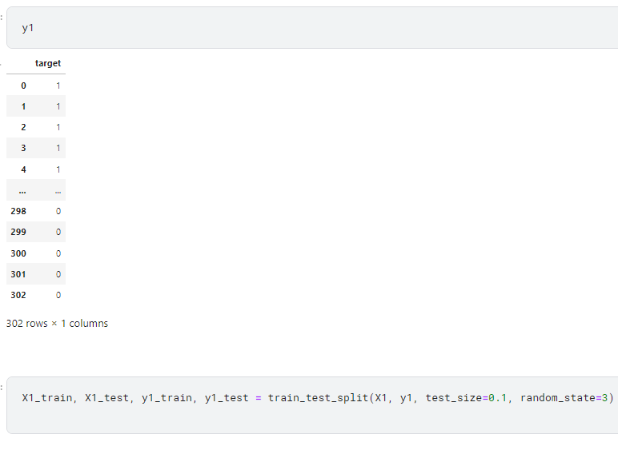

**3.2 Noise Removal(SMOTE Algorithm):** SMOTE, which stands for Synthetic Minority Over-sampling Technique, is an algorithm used in machine learning for addressing class imbalance in datasets. Class imbalance occurs when one class in the target variable has significantly fewer instances than the other class.

SMOTE works by generating synthetic examples of the minority class to balance the class distribution. It does this by creating synthetic instances along the line segments joining existing minority class instances. This helps prevent the model from being biased towards the majority class and improves the performance of machine learning algorithms, particularly in classification tasks where imbalanced classes can lead to poor model generalization.

**Screenshot:**

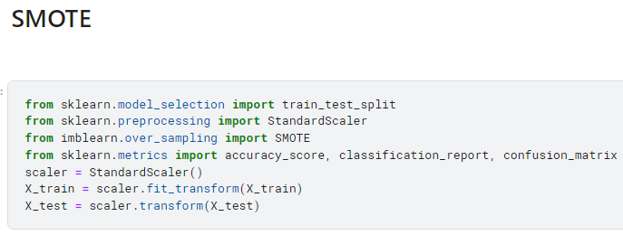

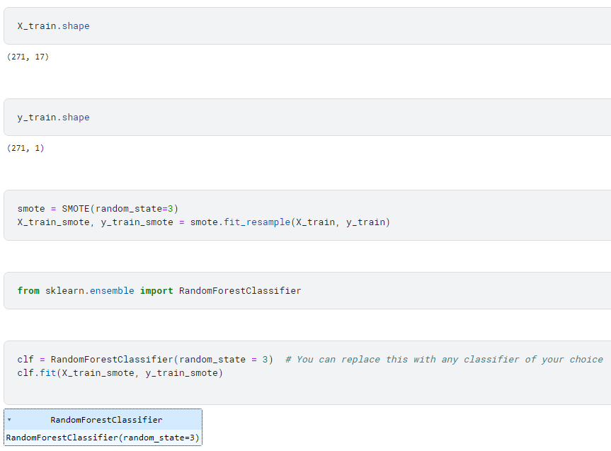

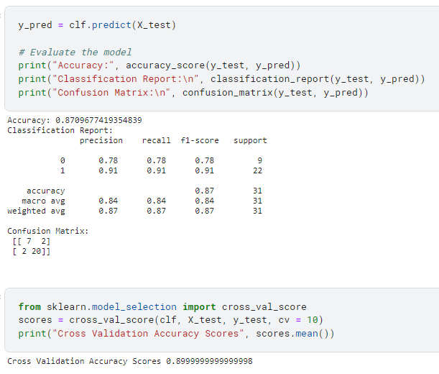

**Inference:**

This code performs several steps related to machine learning, particularly in the context of handling imbalanced datasets.

1. **Data Pre-Processing:**
   * **from sklearn.model_selection import train_test_split**: Imports the **train_test_split** function to split the dataset into training and testing sets.
   * **from sklearn.preprocessing import StandardScaler**: Imports the **StandardScaler** to standardize the feature values.
   * **from imblearn.over_sampling import SMOTE**: Imports the **SMOTE** algorithm from the imbalanced-learn library for oversampling the minority class.
   * **from sklearn.metrics import accuracy_score, classification_report, confusion_matrix**: Imports metrics for evaluating the model.
2. **Standardization:**
   * **scaler = StandardScaler()**: Creates an instance of the **StandardScaler**.
   * **X_train = scaler.fit_transform(X_train)**: Standardizes the training set.
   * **X_test = scaler.transform(X_test)**: Applies the same standardization to the test set.
3. **SMOTE Oversampling:**
   * **smote = SMOTE(random_state=3)**: Creates an instance of the SMOTE algorithm with a specified random state.
   * **X_train_smote, y_train_smote = smote.fit_resample(X_train, y_train)**: Applies SMOTE to the training set to oversample the minority class.
4. **Model Training:**
   * **from sklearn.ensemble import RandomForestClassifier**: Imports the **RandomForestClassifier**.
   * **clf = RandomForestClassifier(random_state=3)**: Creates an instance of the Random Forest classifier.
   * **clf.fit(X_train_smote, y_train_smote)**: Fits the classifier on the oversampled training data.
5. **Model Evaluation:**
   * **y_pred = clf.predict(X_test)**: Makes predictions on the test set.
   * **print("Accuracy:", accuracy_score(y_test, y_pred))**: Prints the accuracy of the model on the test set.
   * **print("Classification Report:\n", classification_report(y_test, y_pred))**: Prints a classification report with precision, recall, and F1-score.
   * **print("Confusion Matrix:\n", confusion_matrix(y_test, y_pred))**: Prints the confusion matrix.
6. **Cross-Validation:**
   * **from sklearn.model_selection import cross_val_score**: Imports cross-validation functionality.
   * **scores = cross_val_score(clf, X_test, y_test, cv=10)**: Performs 10-fold cross-validation and calculates accuracy scores.
   * **print("Cross Validation Accuracy Scores", scores.mean())**: Prints the mean accuracy across the cross-validation folds.

In summary, the code demonstrates the process of handling imbalanced datasets by using SMOTE for oversampling the minority class, training a Random Forest classifier, evaluating its performance on a test set, and assessing generalization through cross-validation.

**3.3 OneHot Encoding:** One-hot encoding is a technique used in machine learning to represent categorical variables as binary vectors. For each unique category in the original variable, a new binary variable (dummy variable) is created. The new variables are set to 1 if the observation belongs to that category and 0 otherwise. This encoding allows machine learning models to effectively interpret and utilize categorical data in a numerical format.

**Screenshot:**

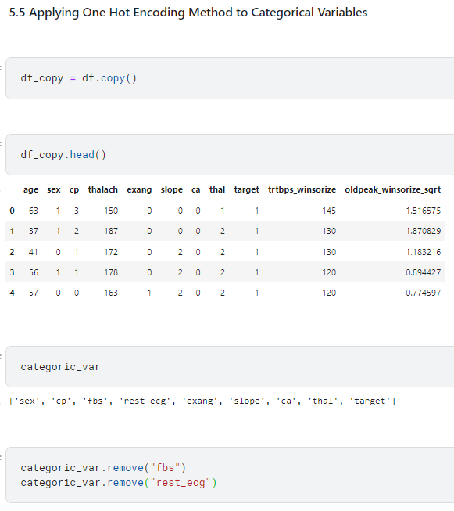

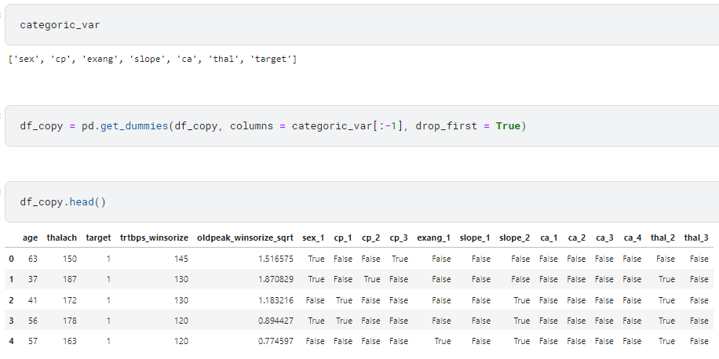

**Inference:**

This code performs the following operations on a DataFrame (**df**) and its copy (**df_copy**):

1. **df_copy = df.copy()**: Creates a copy of the original DataFrame **df** named **df_copy**. This step is often done to preserve the original data.
2. **df_copy.head()**: Displays the first few rows of the copied DataFrame **df_copy**. This line is for observation purposes and doesn't modify the DataFrame.
3. **categoric_var**: This seems to be a variable containing categorical column names. The code then removes the columns "fbs" and "rest_ecg" from this list:
4. **df_copy = pd.get_dummies(df_copy, columns=categoric_var[:-1], drop_first=True)**: Uses one-hot encoding to convert categorical variables in the DataFrame **df_copy** into dummy variables. The columns specified in **categoric_var[:-1]** are one-hot encoded, and the original categorical columns are dropped (**drop_first=True**). This is a common approach to avoid multicollinearity in regression models when dealing with categorical variables.
5. **df_copy.head()**: Displays the first few rows of the DataFrame **df_copy** after the one-hot encoding.

In summary, the code creates a copy of a DataFrame, removes specific categorical columns from the copy, performs one-hot encoding on the remaining categorical columns, and displays the first few rows of the resulting DataFrame.

**Section - 4 (Regression)**

**4.1 Linear Regression:**

**Screenshot:**

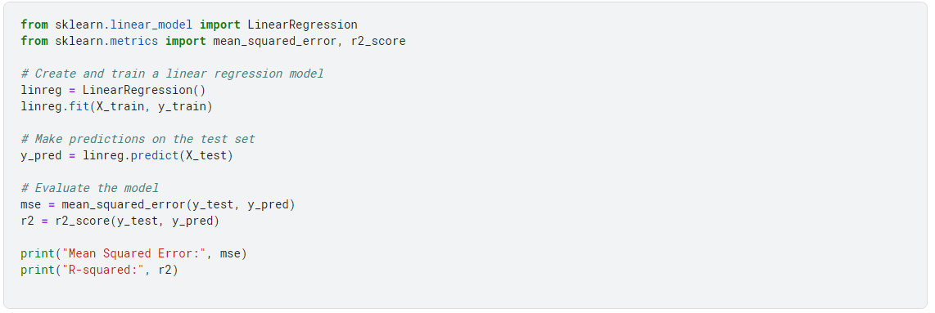

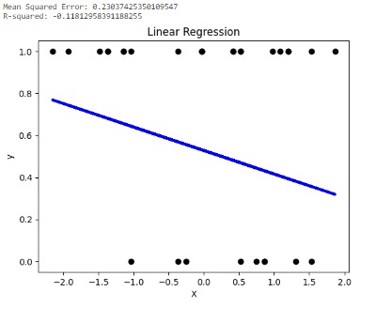

**Inference:**

In the code, a LinearRegression object is created and trained using the fit() method with the training data (X_train as features and y_train as the target). The trained linear regression model (linreg) predicts the target variable for the test set features (X_test), storing the predictions in y_pred. mean_squared_error() calculates the mean squared error between the true target values (y_test) and the predicted values (y_pred). r2_score() computes the R-squared (coefficient of determination) to measure the goodness of fit of the regression model.

The output indicates the performance metrics of the linear regression model on the test set:

* Mean Squared Error: 0.2303 (lower values indicate better performance)
* R-squared: -0.1181 (represents the proportion of variance in the target variable explained by the model, closer to 1 is better)

While these metrics are commonly used for regression tasks, they're not suitable for evaluating classification models like predicting heart attack risk, where accuracy, precision, recall, or F1-score would be more appropriate.

|  |  |  |
| --- | --- | --- |
| **Parameter Name** | **Purpose** | **Value** |
| Test size | To split the dataset into training and testing in a ratio | 0.2 |
| Random State | This parameter sets the seed for the random number generator used by the data splitter. By using a fixed seed, the random splitting process becomes deterministic, allowing for result reproducibility. | 3 |

**4.2 Linear Regression with Hyper-Parameter Tuning:**

**Screenshot:**

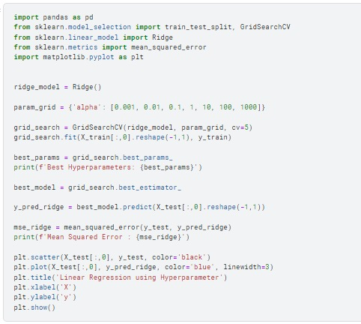

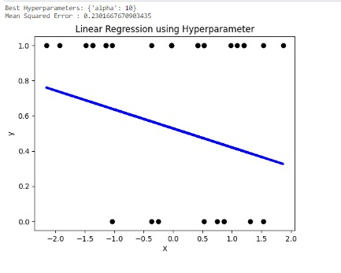

**Inference:**

This code implements Ridge regression with hyperparameter tuning using a grid search approach. It starts by creating a Ridge regression model and defines a grid of alpha values to be tested. The GridSearchCV object is employed to perform a cross-validated grid search, optimizing the model based on the mean squared error. The best hyperparameters are then printed. The script proceeds to extract the best model and uses it to predict the target variable on a separate test set.

The mean squared error between the true and predicted values is calculated and displayed. Finally, a scatter plot is generated to visualize the model's performance on the test set, with the observed values in black and the predicted values in blue. This analysis allows for an assessment of the Ridge regression model's effectiveness in capturing the underlying patterns in the data, considering different regularization strengths.

|  |  |  |
| --- | --- | --- |
| **Parameter Name** | **Purpose** | **Value** |
| Test size | To split the dataset into training and testing in a ratio | 0.2 |
| Random State | This parameter sets the seed for the random number generator used by the data splitter. By using a fixed seed, the random splitting process becomes deterministic, allowing for result reproducibility. | 3 |
| Grid Search | The grid search explores various alpha values using 5-fold cross-validation. | 0.001, 0.01, 0.1, 1, 10, 100, 1000 |

**4.3 Logistic Regression:**

**Screenshot:**







With this code we are training a Logistic Regression model (**log_reg**) on a dataset using SMOTE (Synthetic Minority Over-sampling Technique) for dealing with class imbalance, and then made predictions (**y_pred**) on the test set. The **y_pred** array contains the predicted class labels for the test set samples. Each value (0 or 1) represents the predicted class label for a corresponding test sample.



**Inference:**

The output indicates the test accuracy of the Logistic Regression model, which stands at approximately 83.9%. This accuracy score represents the proportion of correctly predicted instances out of the total test dataset.

**Cross Validation:**



**Inference:**

The cross-validation accuracy scores for the Logistic Regression model. Utilizing a 10-fold cross-validation technique, the average accuracy across multiple validation sets is approximately 76.7%.

**Roc Curve and Area Under Curve (AUC):**

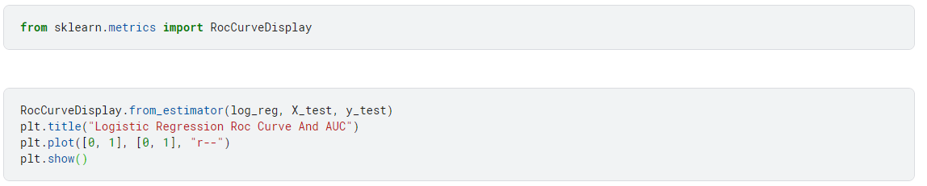

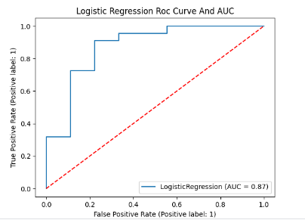

|  |  |  |
| --- | --- | --- |
| **Parameter Name** | **Purpose** | **Value** |
| Test size | To split the dataset into training and testing in a ratio | 0.2 |
| Random State | This parameter sets the seed for the random number generator used by the data splitter. By using a fixed seed, the random splitting process becomes deterministic, allowing for result reproducibility. | 3 |

**4.4 Logistic Regression with Hyper-Parameter Tuning:**

**Screenshot:**

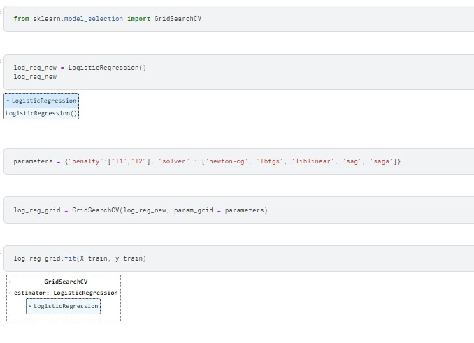

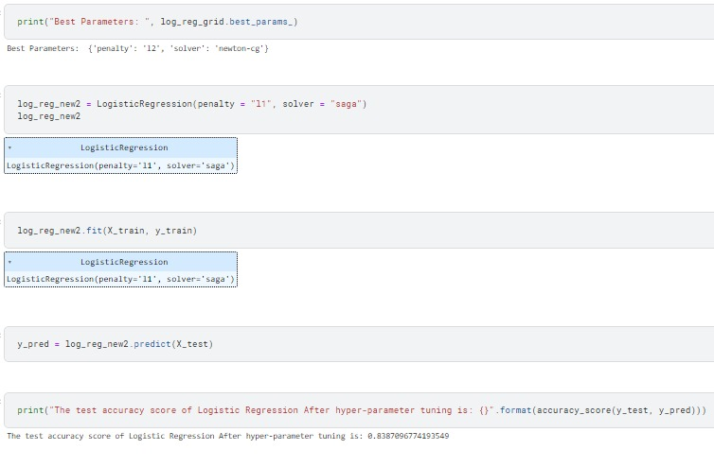

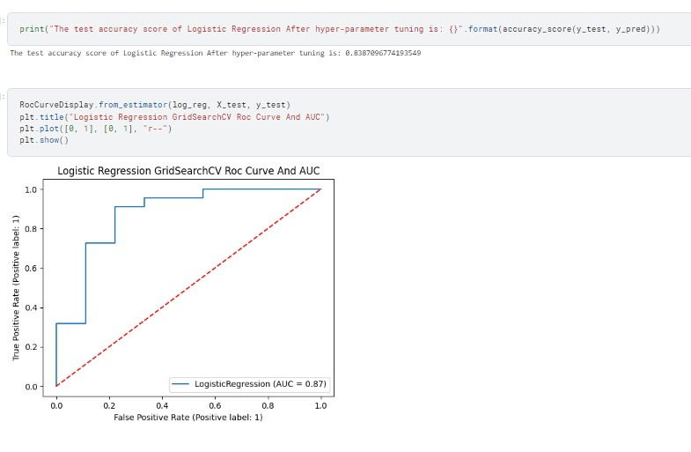

**Inference:**

The code uses the scikit-learn library to perform hyperparameter tuning for a logistic regression model using GridSearchCV.

1. The code begins by importing the necessary modules, including GridSearchCV from scikit-learn for hyperparameter tuning and LogisticRegression for creating logistic regression models.
2. An instance of the LogisticRegression model, named log_reg_new, is created without specifying any hyperparameters.
3. A dictionary named parameters is defined, containing the hyperparameters to be tuned, including penalty type ("l1" or "l2") and solver options ('newton-cg', 'lbfgs', 'liblinear', 'sag', 'saga').
4. A GridSearchCV object named log_reg_grid is instantiated, taking the log_reg_new model and the specified parameter grid.
5. The fit method is called on log_reg_grid with training data (X_train and y_train) to perform the grid search and find the best hyperparameters.
6. The best hyperparameters are printed using log_reg_grid.best_params_.
7. Another instance of the LogisticRegression model, log_reg_new2, is created with specific hyperparameters (penalty = "l1" and solver = "saga").
8. log_reg_new2 is fitted to the training data (X_train and y_train).
9. Predictions are made on the test data (X_test), and the accuracy score of the logistic regression model with the tuned hyperparameters is calculated.
10. The test accuracy score is printed.
11. Lastly, the Receiver Operating Characteristic (ROC) curve and Area Under the Curve (AUC) are plotted for the original logistic regression model (log_reg) using the RocCurveDisplay class.
12. The plot is titled "Logistic Regression GridSearchCV Roc Curve And AUC," and a red dashed line representing a random classifier is included.
13. The plot is displayed using plt.show().

In summary, the code performs hyperparameter tuning for a logistic regression model, evaluates its performance on a test set, and visualizes the ROC curve and AUC. The hyperparameter tuning aims to find the optimal penalty type and solver for the logistic regression model.

|  |  |  |
| --- | --- | --- |
| **Parameter Name** | **Purpose** | **Value** |
| Test size | To split the dataset into training and testing in a ratio | 0.2 |
| Random State | This parameter sets the seed for the random number generator used by the data splitter. By using a fixed seed, the random splitting process becomes deterministic, allowing for result reproducibility. | 3 |
| Grid Search | The grid search explores various alpha values using 5-fold cross-validation. | "penalty":["l1","l2"], "solver" : ['newton-cg', 'lbfgs', 'liblinear', 'sag', 'saga'] |

**4.5 Lasso Regression:**

**Screenshot:**

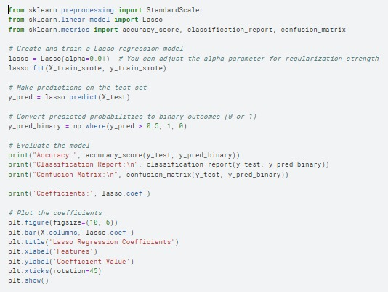

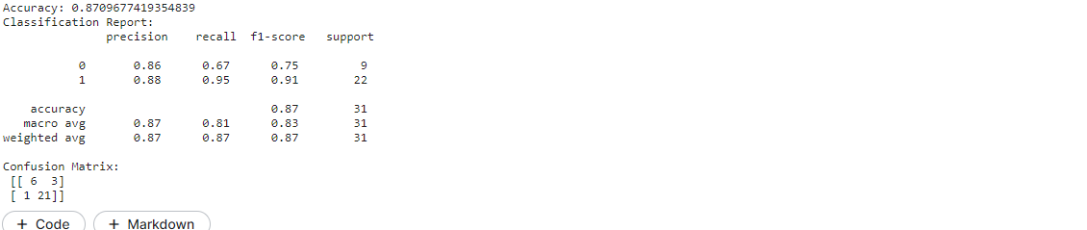

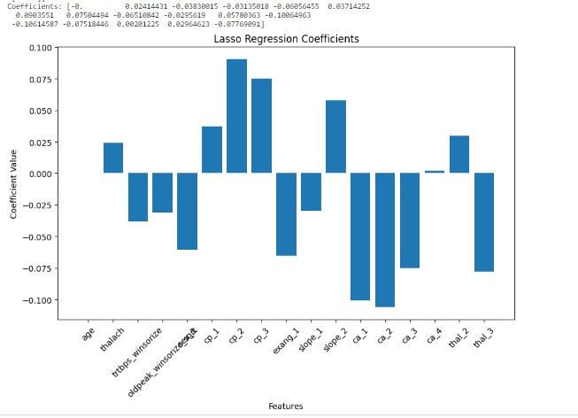

**Inference:**

A **Lasso** object is created with a specified alpha parameter for controlling the strength of regularization. The model is trained using the training data (**X_train_smote** as features and **y_train_smote** as the target). The trained Lasso regression model (**lasso**) predicts the target variable for the test set features (**X_test**), storing the predictions in **y_pred**. The predicted probabilities from the Lasso model are converted into binary outcomes (**0** or **1**) using a threshold of **0.5**.

* **Accuracy**: 0.871 (87.1% accuracy on the test set).
* **Classification Report**: Precision, recall, and F1-score for both classes (0 and 1). Higher values are desired, indicating better performance.
* **Confusion Matrix**: It visually represents the model’s performance, showcasing true positive, true negative, false positive, and false negative predictions. For instance, it correctly predicted 6 instances of class 0 and 21 instances of class 1. However, it misclassified 3 instances of class 0 as class 1 and 1 instance of class 1 as class 0.

|  |  |  |
| --- | --- | --- |
| **Parameter Name** | **Purpose** | **Value** |
| Test size | To split the dataset into training and testing in a ratio | 0.2 |
| Random State | This parameter sets the seed for the random number generator used by the data splitter. By using a fixed seed, the random splitting process becomes deterministic, allowing for result reproducibility. | 3 |
| Alpha | The regularization parameter controls the amount of shrinkage applied to the coefficients of the model | 0.01 |

**4.6 Lasso Regression with Hyper-Parameter Tuning:**

**Screenshot:**

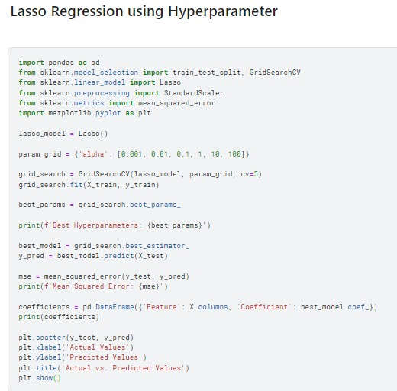

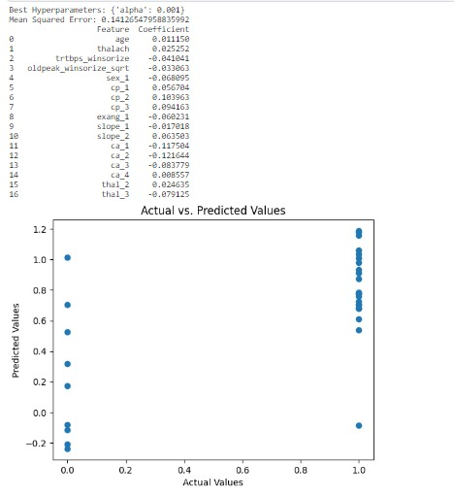

**Inference:**

The code performs Lasso regression with hyperparameter tuning using GridSearchCV and evaluates the model's performance.

1. The code begins by importing necessary libraries, including pandas for data manipulation, train_test_split for splitting the dataset, Lasso for linear regression with L1 regularization, StandardScaler for feature scaling, mean_squared_error for evaluating model performance, and matplotlib.pyplot for visualization.
2. An instance of the Lasso model (lasso_model) is created without specifying hyperparameters.
3. A dictionary named param_grid is defined, containing a range of alpha values to be used in hyperparameter tuning.
4. A GridSearchCV object named grid_search is instantiated, taking the lasso_model, param_grid, and using 5-fold cross-validation.
5. The fit method is called on grid_search with training data (X_train and y_train) to perform the grid search and find the best hyperparameter (alpha) value.
6. The best hyperparameters are extracted using grid_search.best_params_ and printed.
7. The best model (best_model) with the tuned hyperparameter is extracted from grid_search.best_estimator_.
8. Predictions are made on the test data (X_test) using the best model.
9. The mean squared error (MSE) between the true target values (y_test) and the predicted values (y_pred) is calculated and printed.
10. Coefficients of the features in the best model are extracted, and a DataFrame (coefficients) is created to display the features along with their corresponding coefficients.
11. A scatter plot is generated to visualize the relationship between the actual and predicted values on the test set.
12. The x-axis represents the actual values, the y-axis represents the predicted values, and the plot is titled "Actual vs. Predicted Values."
13. The plot is displayed using plt.show().

In summary, the code performs Lasso regression with hyperparameter tuning, prints the best hyperparameters, evaluates the model using mean squared error, displays the feature coefficients, and visualizes the relationship between actual and predicted values.

|  |  |  |
| --- | --- | --- |
| **Parameter Name** | **Purpose** | **Value** |
| Test size | To split the dataset into training and testing in a ratio | 0.2 |
| Random State | This parameter sets the seed for the random number generator used by the data splitter. By using a fixed seed, the random splitting process becomes deterministic, allowing for result reproducibility. | **3** |
| Alpha | The regularization parameter controls the amount of shrinkage applied to the coefficients of the model | 0.01 |
| Grid Search | The grid search explores various alpha values using 5-fold cross-validation. | [0.001, 0.01, 0.1, 1, 10, 100] |

**4.7 Ridge Regression:**

**Screenshot:**

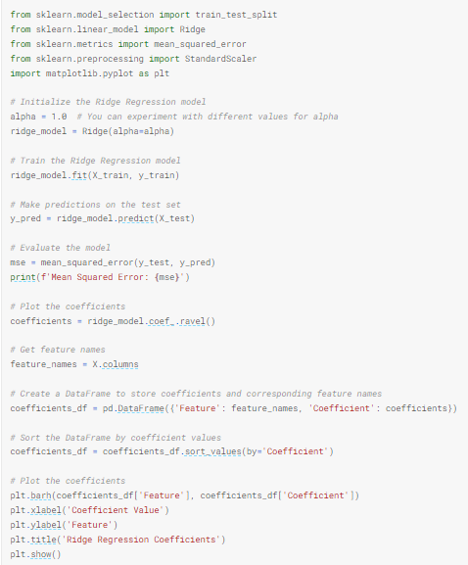

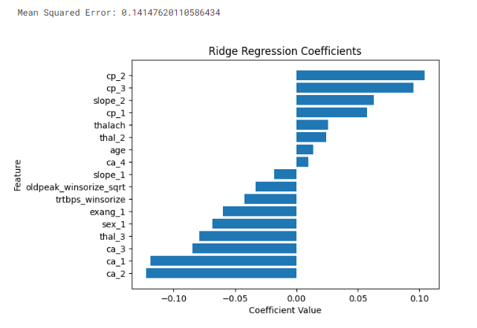

**Inference:**

The Python code implements Ridge Regression on a dataset, utilizing the scikit-learn library. It trains the Ridge Regression model with a regularization parameter (alpha) set to 1.0, makes predictions on a test set, evaluates the model's performance using Mean Squared Error, and visualizes the coefficients of the features through a horizontal bar plot. The plot aids in interpreting the impact of each feature on the model's predictions, with positive and negative coefficients indicating positive and negative influences, respectively. The regularization strength can be adjusted by modifying the alpha parameter.

|  |  |  |
| --- | --- | --- |
| **Parameter Name** | **Purpose** | **Value** |
| Test size | To split the dataset into training and testing in a ratio | 0.2 |
| Random State | This parameter sets the seed for the random number generator used by the data splitter. By using a fixed seed, the random splitting process becomes deterministic, allowing for result reproducibility. | **3** |
| Alpha | The regularization parameter controls the amount of shrinkage applied to the coefficients of the model | 1.0 |

**4.8 Ridge Regression with Hyper-Parameter Tuning:**

**Screenshot:**

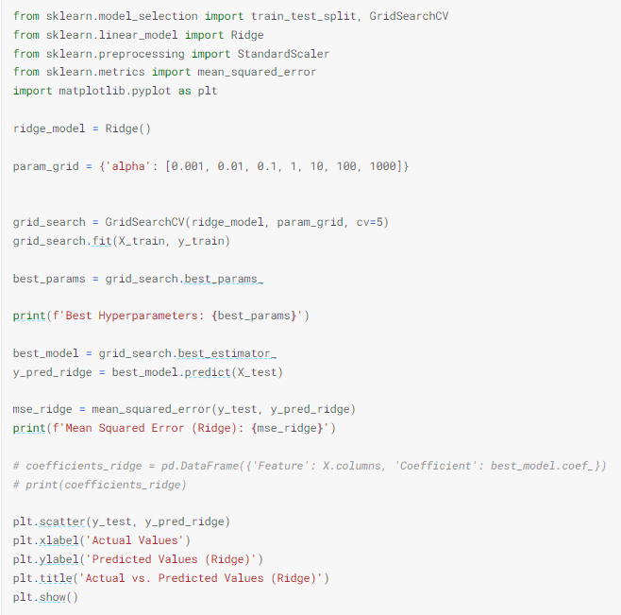

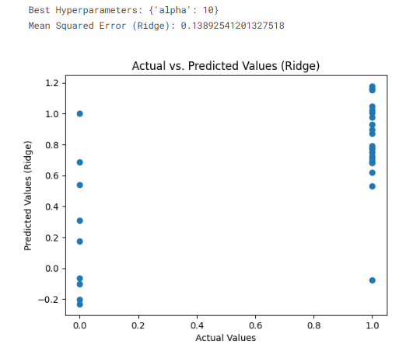

**Inference:**

The Python code conducts hyperparameter tuning for Ridge Regression using Grid Search Cross-Validation. It initializes a Ridge Regression model and defines a grid of alpha values for tuning. Through Grid Search with 5-fold cross-validation, the best hyperparameter values are determined. The code then prints the best hyperparameters, obtains the corresponding Ridge Regression model, and makes predictions on the test set. The Mean Squared Error (MSE) is calculated to assess the model's performance. Lastly, a scatter plot is generated to visually compare the actual and predicted values of the target variable using the Ridge Regression model.

|  |  |  |
| --- | --- | --- |
| **Parameter Name** | **Purpose** | **Value** |
| Test size | To split the dataset into training and testing in a ratio | 0.2 |
| Random State | This parameter sets the seed for the random number generator used by the data splitter. By using a fixed seed, the random splitting process becomes deterministic, allowing for result reproducibility. | 3 |
| Alpha | The regularization parameter controls the amount of shrinkage applied to the coefficients of the model | 1.0 |
| Grid Search CV | The grid search explores various alpha values using 5-fold cross-validation. | 0.001, 0.01, 0.1, 1, 10, 100, 1000 |

|  |  |  |  |  |
| --- | --- | --- | --- | --- |
|  | **Parameter -1 (Test Size)** | **Parameter -2**  **(Random State)** | **Parameter -3**  **(Alpha)** | **Parameter -4**  **(Grid Search CV)** |
| **Linear without Hyperparameter** | 0.2 | 3 | - | **-** |
| **Linear with Hyperparameter** | 0.2 | 3 | - | 0.001, 0.01, 0.1, 1, 10, 100, 1000 |
| **Logistic without Hyperparameter** | 0.2 | 3 | - | **-** |
| **Logistic with Hyperparameter** | 0.2 | 3 | 0.01 | "penalty":["l1","l2"], "solver" : ['newton-cg', 'lbfgs', 'liblinear', 'sag', 'saga'] |
| **Lasso without Hyperparameter** | 0.2 | 3 | 0.01 | **-** |
| **Lasso with Hyperparameter** | 0.2 | 3 | 0.01 | 0.001, 0.01, 0.1, 1, 10, 100, 1000 |
| **Ridge without Hyperparameter** | 0.2 | 3 | 1.0 | **-** |
| **Ridge with Hyperparameter** | 0.2 | 3 | 1.0 | 0.001, 0.01, 0.1, 1, 10, 100, 1000 |

**4.9 Comparison of Regression Models:**

**4.10 SVM:**

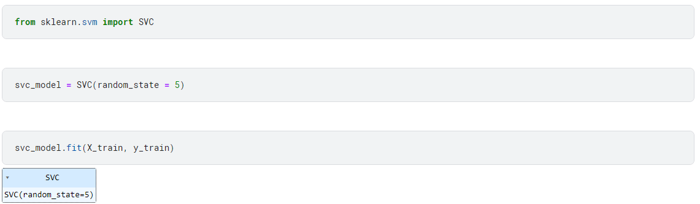

Inference:

svc_model = SVC(random_state = 5)

This line initializes a Support Vector Classifier (SVC) model using Scikit-learn, setting the random state to 5 for reproducibility.

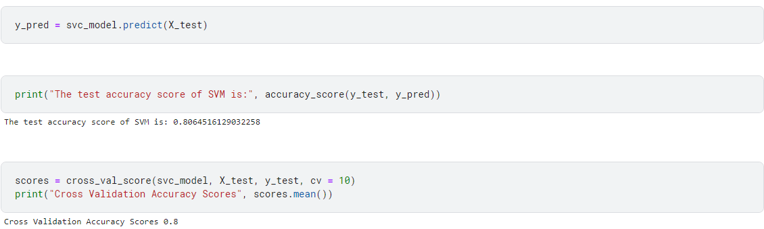

**Inference:**

The output showcases the **test accuracy score** of the Support Vector Machine (SVM) model, which is 0.806 or approximately **80.6%**.

The second output demonstrates the **cross-validation accuracy score** of the Support Vector Machine (SVM) model, using a 10-fold cross-validation technique. The mean accuracy score across the 10 cross-validation folds is 0.8 or **80%**.

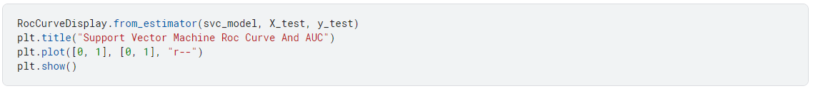

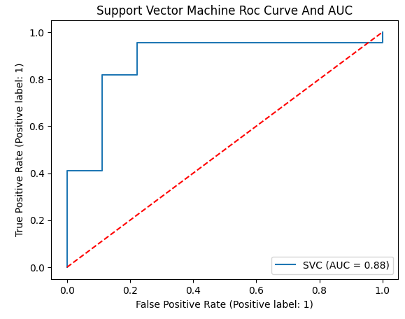

**4.11 Random Forest Algorithm:**

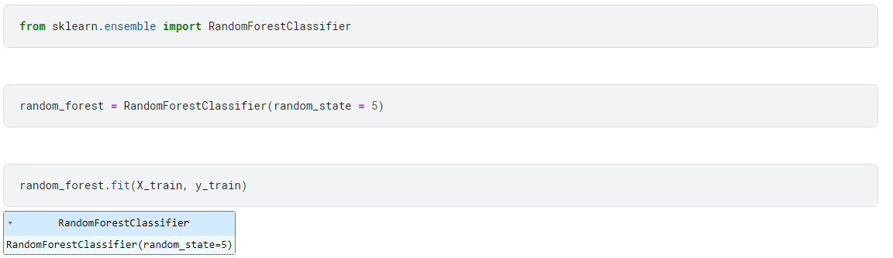

We are initializing a Random Forest Classifier using Scikit-learn, setting the random state to 5 for reproducibility. Then, trained a Random Forest Classifier (**random_forest**) on the training data (**X_train** and **y_train**) and made predictions on the test data (**X_test**).

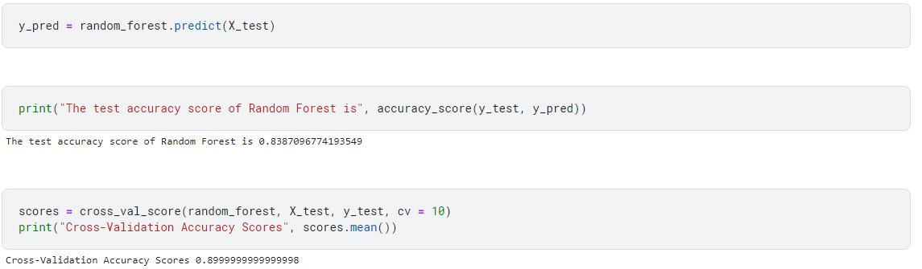

**Inference:**

The output indicates the **performance score** on the test set is approximately **83.9%**. This score represents the proportion of correctly predicted instances out of the total test dataset. Then, the **cross-validation accuracy scores**, computed using a 10-fold cross-validation, have a mean value of **approximately 90%**.

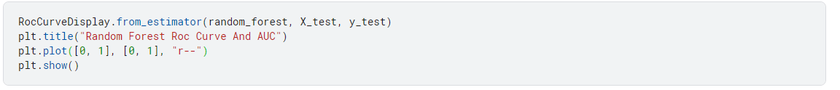

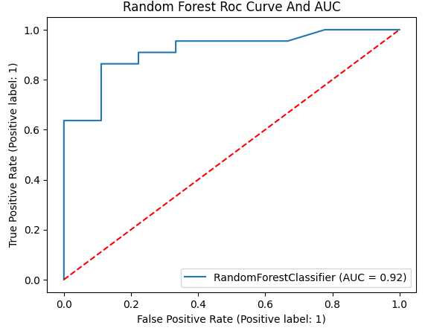

**Section - 5 (Classifiers)**

**5.1 K-Means with KNN:**

**Screenshot:**

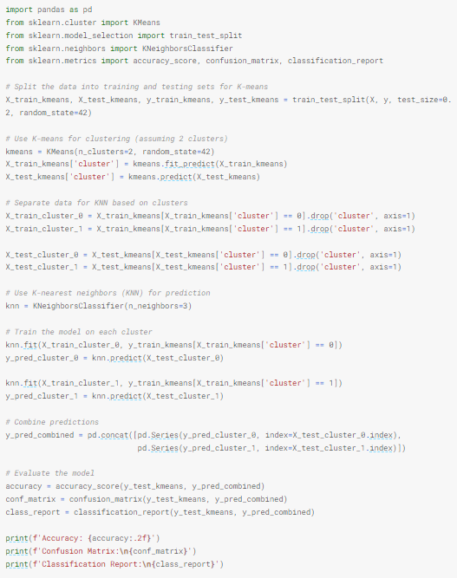

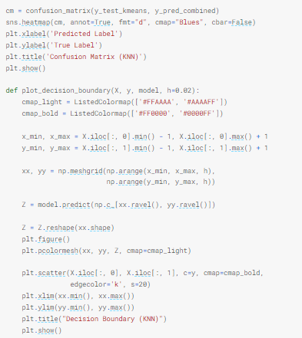

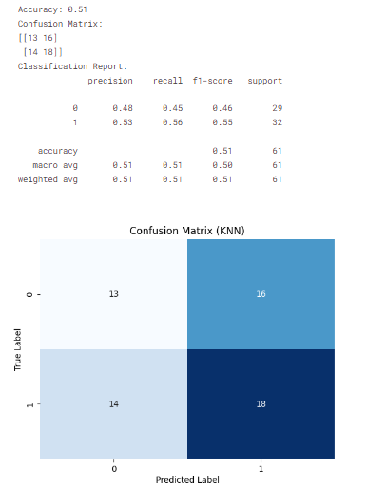

**Inference:**

The Python code integrates K-Means clustering with K-Nearest Neighbours (KNN) for predictive modelling on a Heart Prediction and Analysis dataset. Initially, the dataset is split into training and testing sets, and K-Means clustering is applied with two clusters. The data is then separated based on these clusters, forming distinct subsets for subsequent KNN model training. Two separate KNN models are trained on each cluster, accommodating distinct patterns within the clusters. Subsequently, predictions are made for the corresponding test data from both clusters. These predictions are combined to form an aggregated prediction set.

The model's performance is evaluated using standard classification metrics such as accuracy, a confusion matrix, and a classification report. The confusion matrix heatmap visually illustrates the predictive performance of the combined K-Means and KNN model. Additionally, a decision boundary is visualized to aid in understanding how the KNN model delineates regions in the feature space for different classes. This comprehensive approach aims to leverage both clustering and classification techniques to enhance predictive accuracy and interpretability in the context of the Heart Prediction and Analysis dataset.

**5.2 K-Means with KNN with Hyper-Parameter Tuning:**

**Hyperparameter Tuning approach used:** Grid Search CV

**Screenshot:**

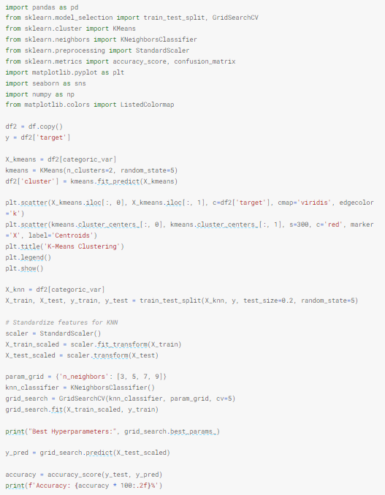

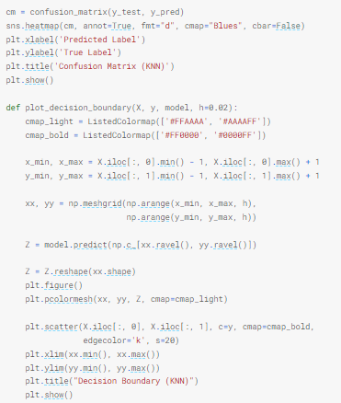

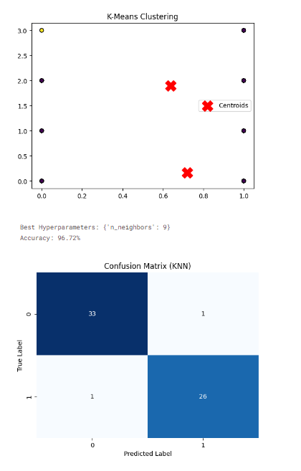

**Inference:**

The Python code integrates K-Means clustering and K-Nearest Neighbours (KNN) classification on a dataset, emphasizing categorical variables. Initially, K-Means clustering is applied to the categorical variables, creating two clusters. The resulting clusters are visualized alongside their centroids in a scatter plot. Following this, the dataset is split into training and testing sets for KNN classification. Standardization is performed on the features, and a grid search is conducted to optimize the number of neighbours in the KNN classifier.

The code evaluates the KNN model's accuracy and displays a heatmap of the confusion matrix to assess its classification performance. Additionally, a decision boundary visualization is presented, aiding in the interpretation of the KNN model's classification regions within the categorical feature space. This comprehensive approach leverages both clustering and classification techniques, providing insights into the inherent structure of the data and the predictive performance of the KNN model, particularly in the context of categorical variables.

|  |  |  |
| --- | --- | --- |
| **Parameter Name** | **Purpose** | **Value** |
| Test size | To split the dataset into training and testing in a ratio | 0.2 |
| Random State | This parameter sets the seed for the random number generator used by the data splitter. By using a fixed seed, the random splitting process becomes deterministic, allowing for result reproducibility. | 42 |
| No. of Clusters | Number of the centroid which will be formed | 2 |
| Grid Search CV | The grid search explores various alpha values using 5-fold cross-validation. | n_neighbors: 3, 5, 7, 9 |

**5.3 Fuzzy C-Means with KNN with Hyper-Parameter Tuning:**

**Hyperparameter Tuning approach used:** Grid Search CV

**Screenshot:**

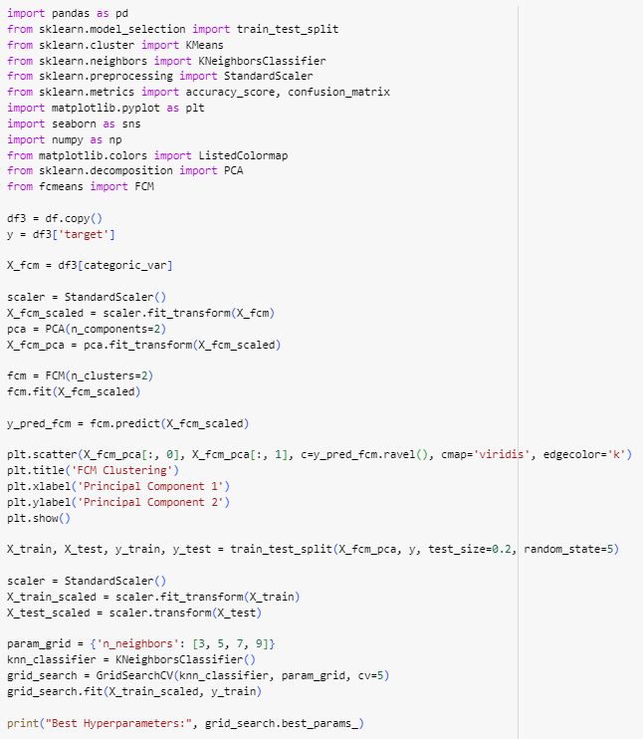

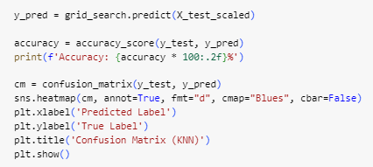

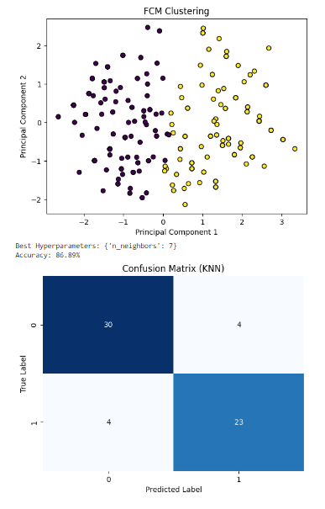

**Inference:**

The code conducts a multi-step analysis on a dataset. It begins by copying the original DataFrame and extracting the target variable. A subset of features, determined by categorical variables, is selected. Standard scaling is then applied to these features, and Principal Component Analysis (PCA) is employed for dimensionality reduction, resulting in two principal components. Fuzzy C-Means (FCM) clustering with two clusters is applied to the scaled features, and predictions are made based on the FCM model. A scatter plot is generated to visualize the clusters. Subsequently, the data is split into training and testing sets for K-Nearest Neighbours (KNN) classification.

The selected features undergo additional standard scaling, and a grid search is performed to optimize the number of neighbours in the KNN algorithm. The best hyperparameters are printed, and the KNN model is trained and evaluated on the testing set. The accuracy of the KNN model is displayed. Finally, a confusion matrix is calculated and visualized using a heatmap, providing insights into the model’s performance in terms of true positive, true negative, false positive, and false negative predictions. The overall approach involves an initial clustering step with FCM followed by a classification step with KNN, leveraging the benefits of both techniques for pattern recognition and classification tasks.

|  |  |  |
| --- | --- | --- |
| **Parameter Name** | **Purpose** | **Value** |
| Test size | To split the dataset into training and testing in a ratio | 0.2 |
| Random State | This parameter sets the seed for the random number generator used by the data splitter. By using a fixed seed, the random splitting process becomes deterministic, allowing for result reproducibility. | 5 |
| No. of Clusters | Number of the centroid which will be formed | 2 |
| The fuzziness index or the fuzzifier | controls the degree of fuzziness in the clustering process. The value of "m" determines how much each data point can belong to multiple clusters. | m = 2 |
| Grid Search CV | The grid search explores various alpha values using 5-fold cross-validation. | n_neighbors: 3, 5, 7, 9 |

**5.4 K-Means with SVM with Hyper-Parameter Tuning:**

**Hyperparameter Tuning approach used:** Grid Search CV

**Screenshot:**

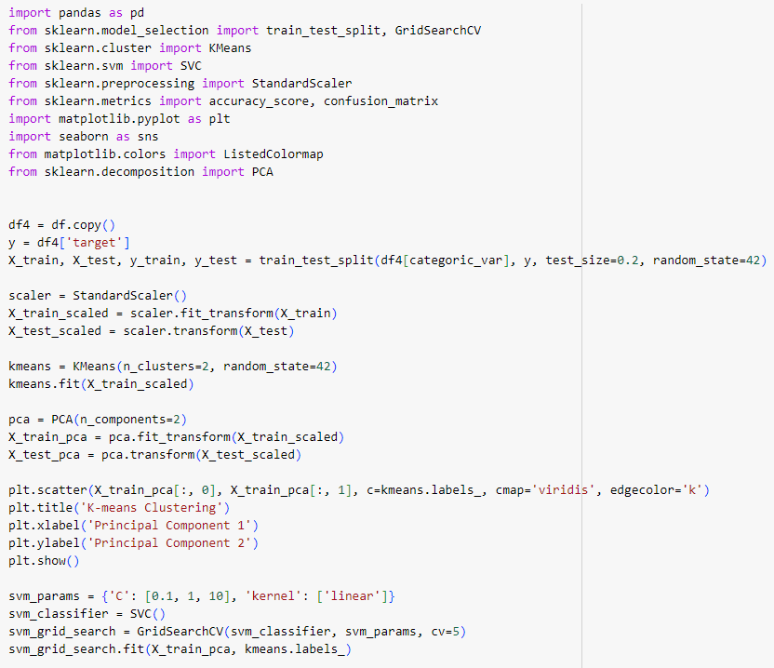

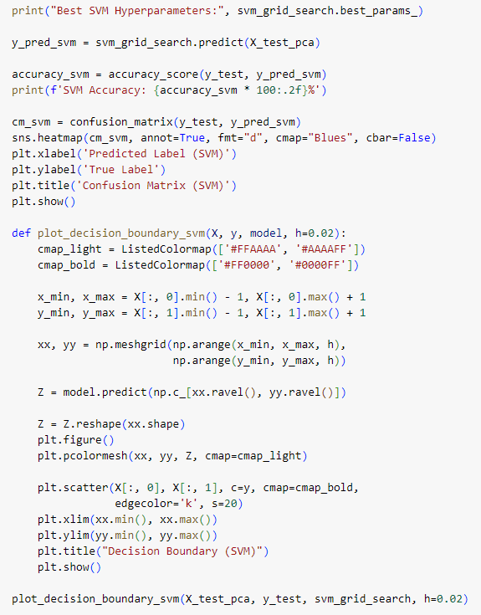

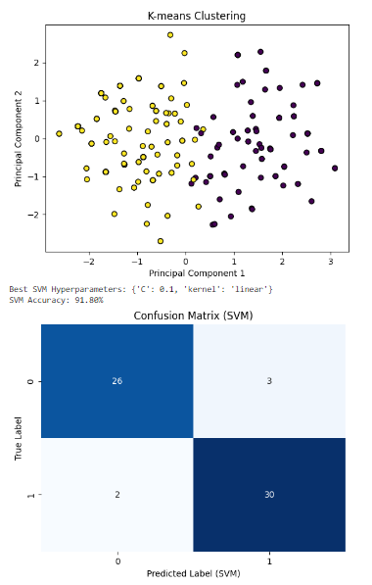

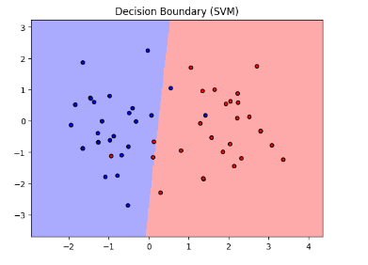

**Inference:**

The Python code conducts a comprehensive analysis of a heart health dataset using both K-means clustering and Support Vector Machine (SVM) classification techniques. Initially, the dataset is preprocessed and split into training and testing sets. K-means clustering is then applied to the scaled training data to identify natural groupings within the dataset. The results are visualized in a scatter plot, allowing for an intuitive understanding of the clustering. Subsequently, the principal component analysis (PCA) is employed to reduce the dimensionality of the data for visualization purposes.

The SVM classifier is then trained on the PCA-transformed training data using a linear kernel, with hyperparameters optimized through a grid search. The SVM model is evaluated on the test set, and the accuracy is calculated. A confusion matrix is generated and visualized using seaborn to provide insights into the performance of the SVM classifier. Additionally, a custom function is defined to plot the decision boundary of the SVM model, enhancing interpretability. This analysis aims to comprehensively assess the dataset's structure, classify distinct clusters, and evaluate the predictive performance of the SVM model in distinguishing between individuals with and without heart disease. It is important to note that the 'target' variable is assumed to be a binary indicator for heart disease presence or absence in the dataset. Before running the code, it is essential to ensure that the dataset and required variables are appropriately defined.

|  |  |  |
| --- | --- | --- |
| **Parameter Name** | **Purpose** | **Value** |
| Test size | To split the dataset into training and testing in a ratio | 0.2 |
| Random State | This parameter sets the seed for the random number generator used by the data splitter. By using a fixed seed, the random splitting process becomes deterministic, allowing for result reproducibility. | 42 |
| Kernel | kernel is a function that computes the dot product of two data points in a transformed feature space. | Linear |
| Cross-validation | The purpose of cross-validation is to evaluate the model's performance for different combinations of hyperparameters. | 5 |
| Grid Search CV | The grid search explores various alpha values using 5-fold cross-validation. | 0.1, 1, 10 |

**5.5 Bayesian Classifier:**

**Screenshot:**

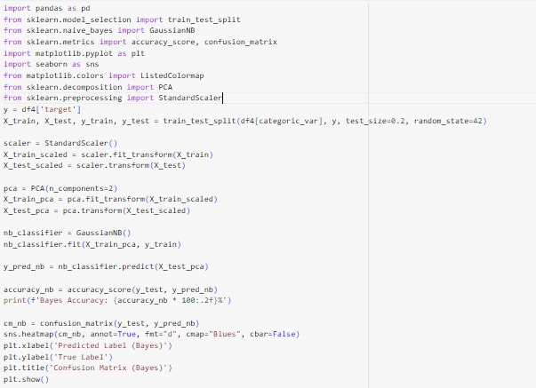

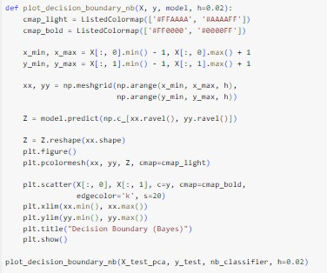

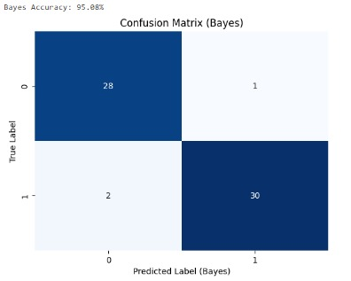

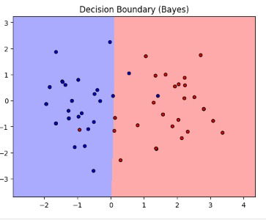

**Inference:**  
The Python code demonstrates the application of Bayes classification to a heart health dataset. The dataset is initially preprocessed, with features scaled using StandardScaler and dimensionality reduced to two principal components through PCA. The Bayes classifier is then trained on the PCA-transformed training data, and its performance is evaluated on the test set. The accuracy of the model is calculated, and a confusion matrix is generated to provide insights into the classification performance, visually represented using seaborn's heatmap. Furthermore, a custom function is defined to plot the decision boundary of the Bayes model, allowing for a graphical representation of the regions classified by the model. The analysis aims to assess the Bayes classifier's ability to predict the presence or absence of heart disease based on the reduced-dimensional features. It is important to ensure that the 'target' variable in the dataset represents the binary indicator for heart disease presence or absence. The code provides a comprehensive overview of the classification performance and decision boundary visualization for the Naive Bayes model in the context of heart health prediction.

**5.6 Bayesian Classifier with Hyper-Parameter Tuning:**

**Hyperparameter Tuning approach used:** Grid Search CV

**Screenshot:**

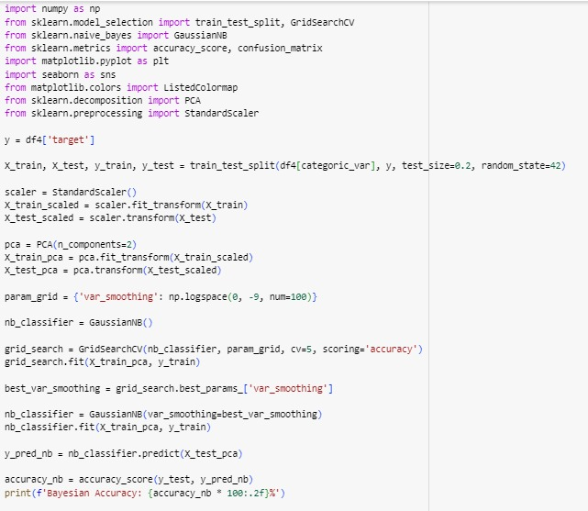

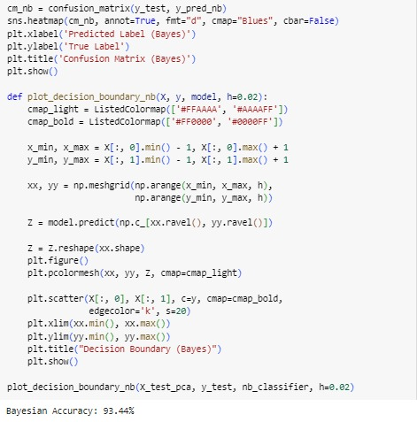

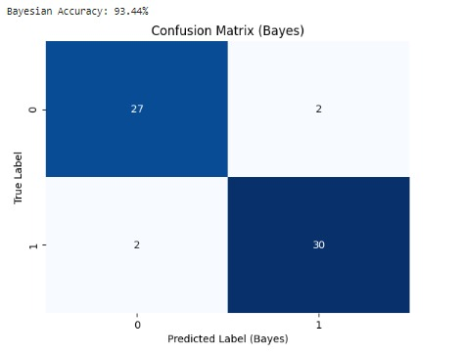

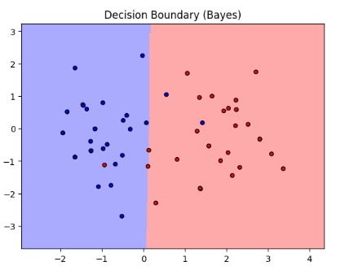

**Inference:**

The Python code involves the application of Bayes classification to a heart health dataset with an additional step for hyperparameter tuning using GridSearchCV. The dataset is preprocessed by scaling the features and reducing dimensionality to two principal components using PCA. The Bayes model is then trained on the training set, and hyperparameter tuning is performed using GridSearchCV to find the optimal value for 'var_smoothing,' which represents the portion of the largest variance of all features that is added to variances for calculation stability.

The best hyperparameter is identified, and the Bayes model is retrained with this optimal parameter. The accuracy of the model is calculated on the test set, and a confusion matrix is generated to assess the classification performance. Additionally, a custom function is defined to plot the decision boundary of the Bayes model, visually representing the regions classified by the model.

The analysis aims to evaluate the impact of hyperparameter tuning on the classification accuracy and decision boundary of the Bayes model in predicting heart disease. The decision boundary plot provides insights into the regions of feature space that the model considers for different class predictions. It's crucial to ensure that the 'target' variable in the dataset represents the binary indicator for heart disease presence or absence.

In summary, the code facilitates an in-depth assessment of the Bayes model's performance, considering both hyperparameter tuning and visualization of decision boundaries. The interpretation of results should consider the specific characteristics of the heart health dataset under consideration.

|  |  |  |
| --- | --- | --- |
|  | **Purpose** | **Value** |
| Test size | To split the dataset into training and testing in a ratio | 0.2 |
| Random State | This parameter sets the seed for the random number generator used by the data splitter. By using a fixed seed, the random splitting process becomes deterministic, allowing for result reproducibility. | 42 |
| Grid Search CV | The grid search explores various alpha values using 5-fold cross-validation. | np.logspace(0, -9, num=100) |

**5.7 Naïve Bayes:**

**Screenshot:**

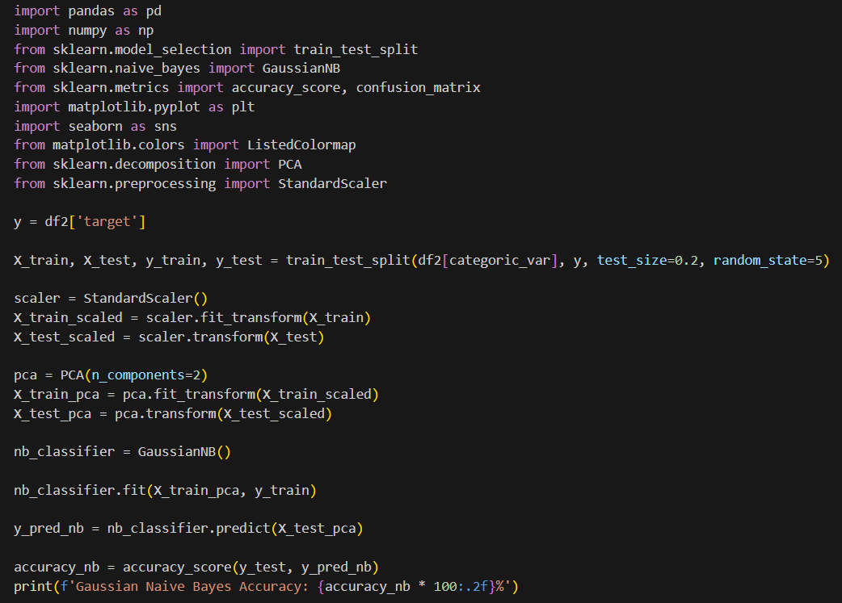

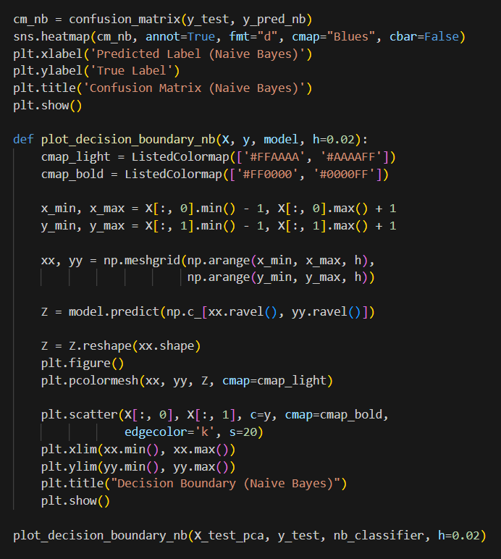

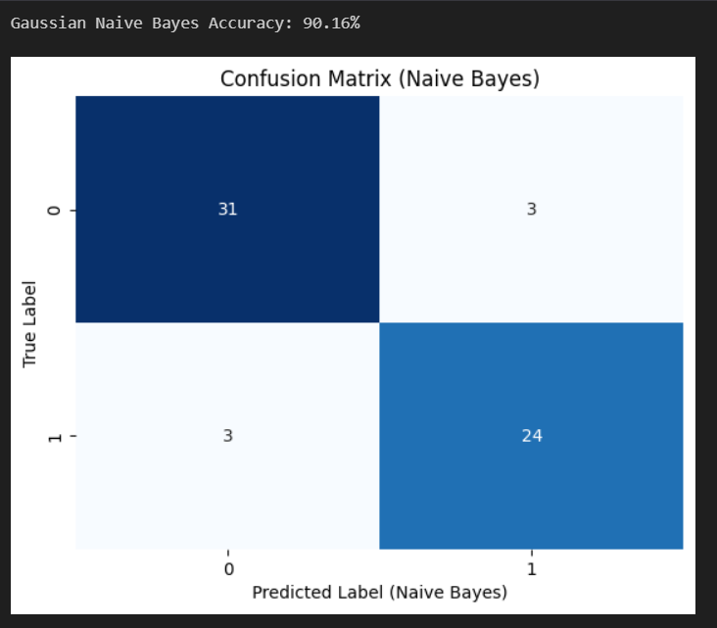

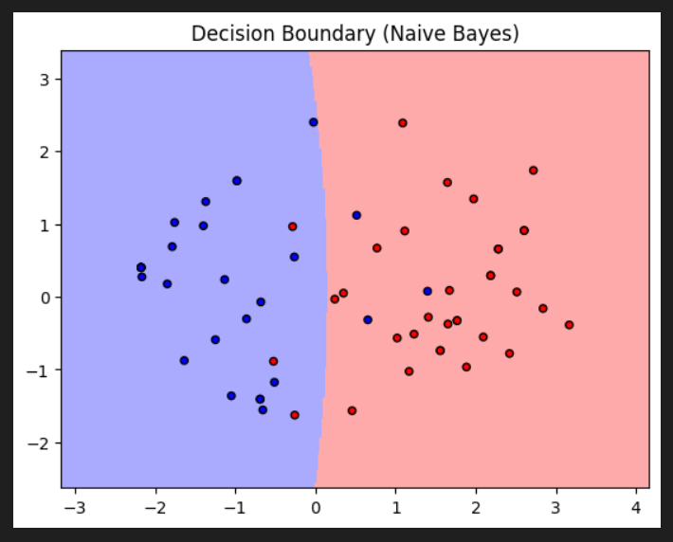

**Inference:**

The Python code demonstrates the application of a Gaussian Naive Bayes classifier to predict heart health based on a dataset (**df2**) with categorical features and a binary target variable named 'target.' The initial steps involve splitting the data into training and testing sets and standardizing the features using **StandardScaler** to ensure consistent scaling. Dimensionality reduction is performed through Principal Component Analysis (PCA), reducing the features to two principal components for visualization purposes in a 2D space.

Subsequently, a Gaussian Naive Bayes classifier is instantiated, trained on the PCA-transformed training data, and evaluated on the test set using metrics such as accuracy. The confusion matrix is employed to gain insights into the model's classification performance, revealing true positives, true negatives, false positives, and false negatives.

To enhance interpretability, a custom function, **plot_decision_boundary_nb**, is defined to visualize the decision boundary of the Naive Bayes classifier in the reduced feature space. This visual representation aids in understanding how well the model separates the two classes.

The overall inference includes an assessment of the model's accuracy, a detailed examination of the confusion matrix, and a visual representation of the decision boundary. It's important to note that the interpretation of results should consider dataset-specific characteristics and the underlying assumptions of the Naive Bayes algorithm, particularly its assumption of feature independence.

**5.8 Naïve Bayes with Hyper-Parameter Tuning:**

**Hyperparameter Tuning approach used:** Grid Search CV

**Screenshot:**

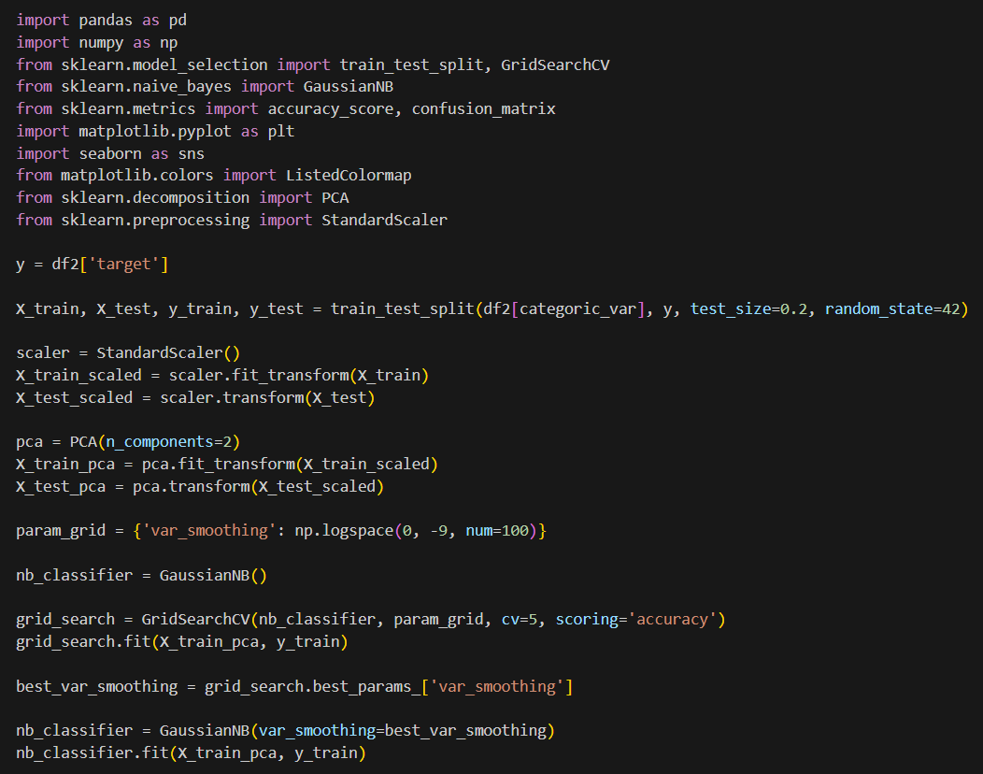

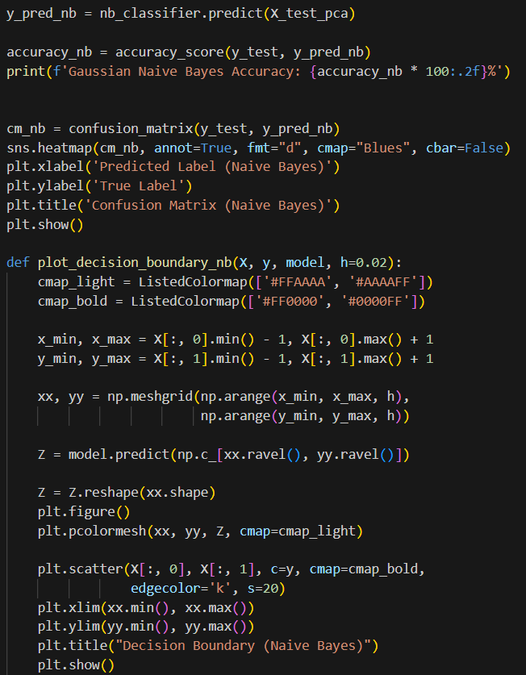

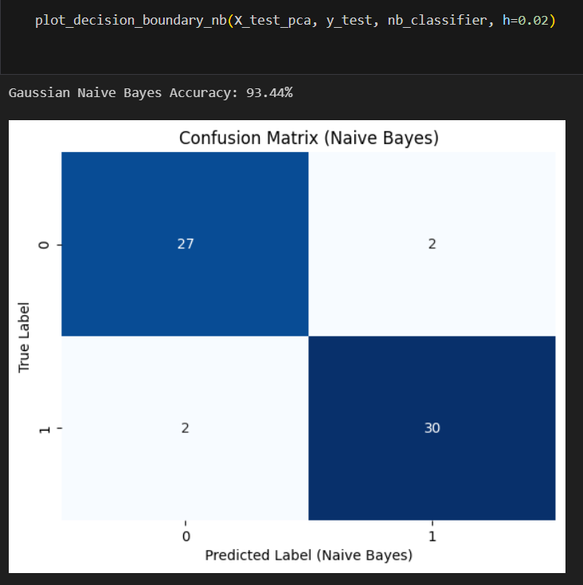

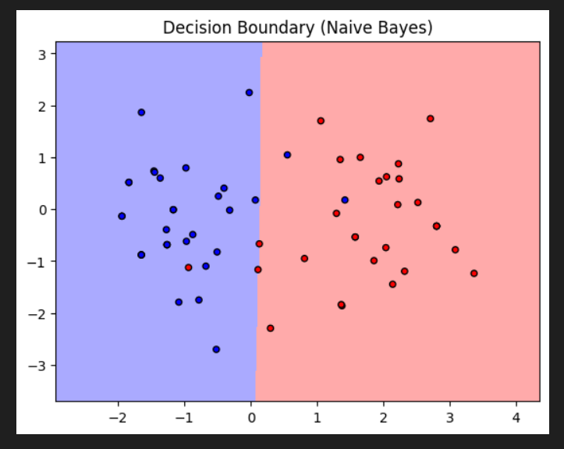

**Inference:**

The presented Python code entails the implementation of a Gaussian Naive Bayes classifier for heart health prediction using a dataset (df2) with categorical features. The code initiates by splitting the data into training and testing sets, standardizing the features with StandardScaler, and then applying Principal Component Analysis (PCA) for dimensionality reduction to visualize the data in a 2D space.

To optimize the Naive Bayes classifier, a grid search is conducted over a range of hyperparameter values (var_smoothing) using GridSearchCV with 5-fold cross-validation. The best hyperparameter is determined based on accuracy scores during the grid search. The Naive Bayes classifier is then instantiated with the optimal hyperparameter and trained on the PCA-transformed training data.

The accuracy of the Gaussian Naive Bayes model is evaluated on the test set, and the results are printed. Additionally, a confusion matrix is generated to provide a detailed breakdown of the model's classification performance, illustrating true positives, true negatives, false positives, and false negatives. The heatmap visualization enhances the interpretability of the confusion matrix.

To visually understand how the Naive Bayes classifier separates classes in the reduced feature space, a custom function named plot_decision_boundary_nb is defined. The function generates a decision boundary plot along with the scatter plot of data points, aiding in the assessment of the model's discriminative capabilities.

In summary, the inference includes the accuracy of the Naive Bayes model, a detailed confusion matrix, and a visual representation of the decision boundary. These results offer valuable insights into the classification performance of the Gaussian Naive Bayes algorithm on the heart health dataset.

|  |  |  |
| --- | --- | --- |
| **Parameter Name** | **Purpose** | **Value** |
| Test size | To split the dataset into training and testing in a ratio | 0.2 |
| Random State | This parameter sets the seed for the random number generator used by the data splitter. By using a fixed seed, the random splitting process becomes deterministic, allowing for result reproducibility. | **42** |
| Grid Search CV | The grid search explores various alpha values using 5-fold cross-validation. | np.logspace(0, -9, num=100) |

**5.8 Decision Tree:**

**Screenshot:**

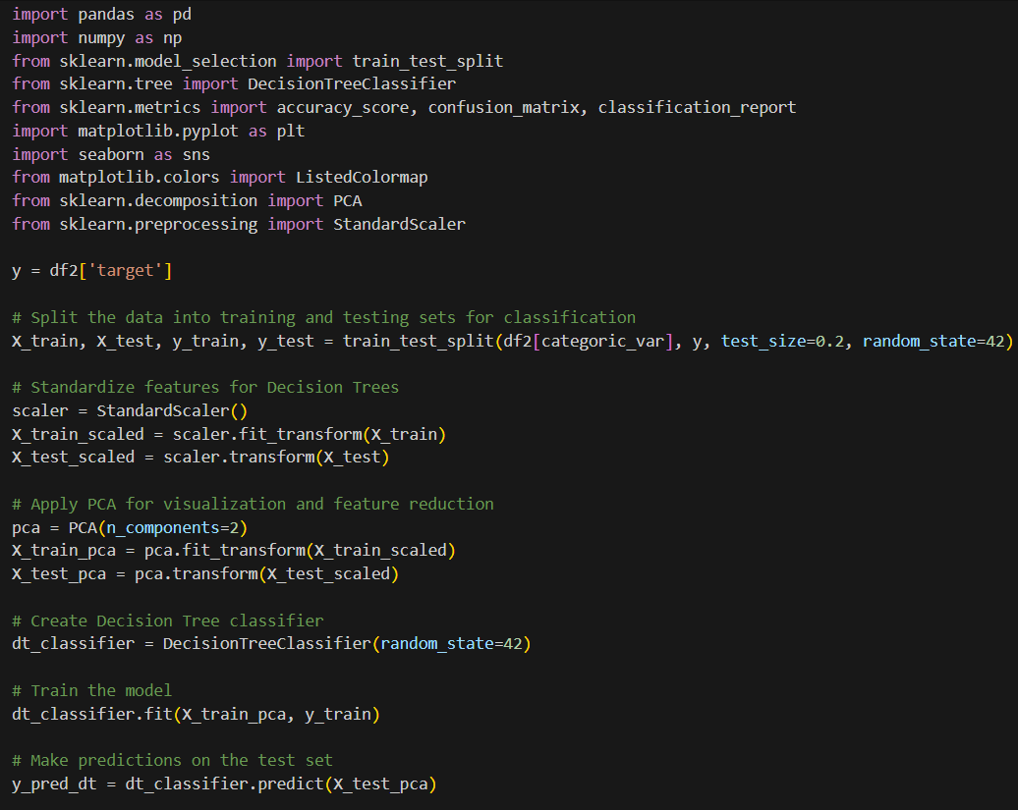

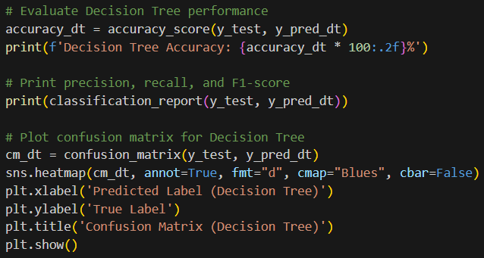

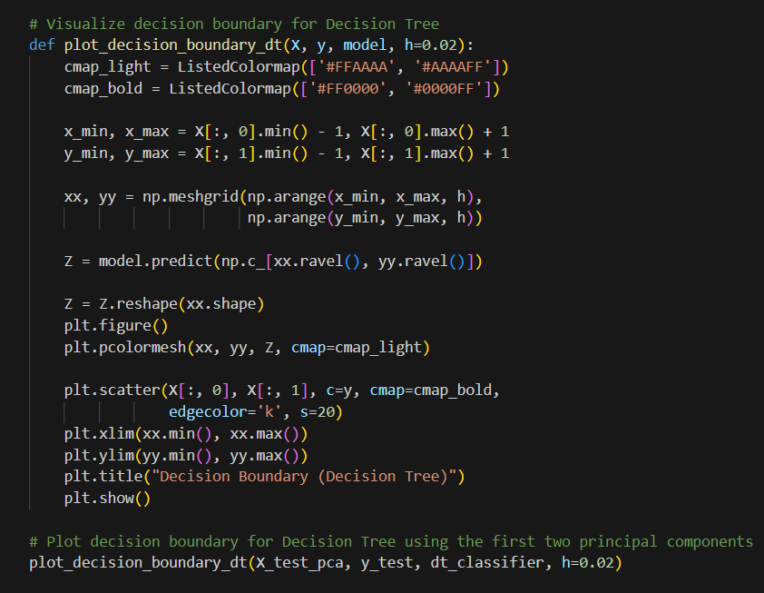

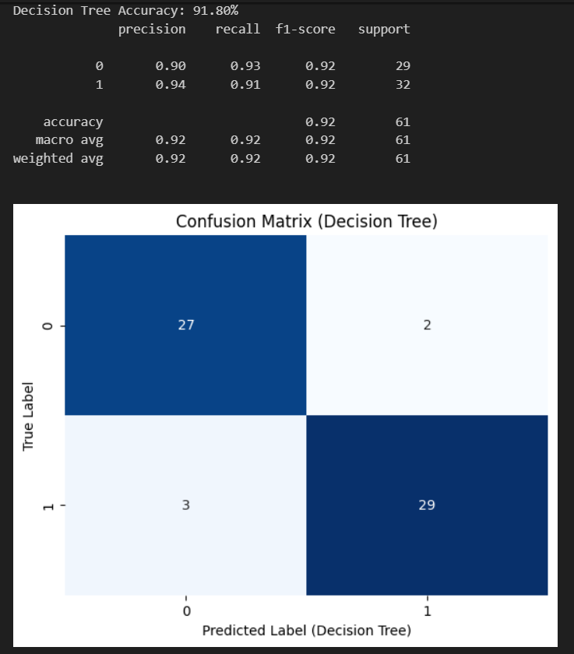

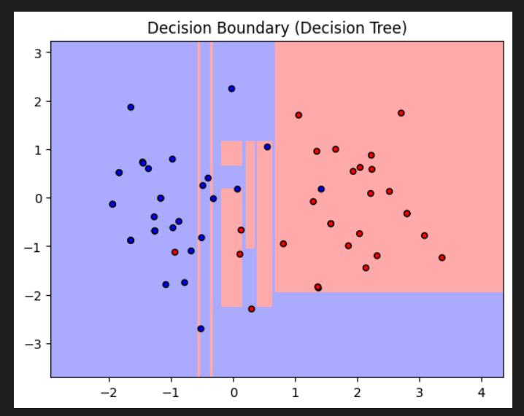

**Inference:**

The Python code demonstrates the implementation of a Decision Tree classifier for heart health prediction using a dataset (df2) with categorical features. The code begins by splitting the data into training and testing sets, standardizing the features with StandardScaler, and then applying Principal Component Analysis (PCA) for dimensionality reduction to visualize the data in a 2D space.

A Decision Tree classifier is instantiated and trained on the PCA-transformed training data. Subsequently, predictions are made on the test set, and the accuracy of the model is evaluated. Additionally, a classification report is generated, which includes precision, recall, and F1-score for each class, providing a comprehensive performance overview.

To further assess the model's classification performance, a confusion matrix is created and visualized using a heatmap. The confusion matrix illustrates true positives, true negatives, false positives, and false negatives, offering insights into the classifier's ability to correctly classify instances.

To gain a visual understanding of how the Decision Tree classifier separates classes in the reduced feature space, a custom function named plot_decision_boundary_dt is defined. This function generates a decision boundary plot along with a scatter plot of data points, aiding in the assessment of the model's discriminative capabilities.

In summary, the inference includes the accuracy of the Decision Tree model, a detailed classification report, a confusion matrix, and a visual representation of the decision boundary. These results offer valuable insights into the classification performance of the Decision Tree algorithm on the heart health dataset.

**5.9 Decision Tree with Hyper-Parameter Tuning:**

**Hyperparameter Tuning approach used:** Grid Search CV

**Screenshot:**

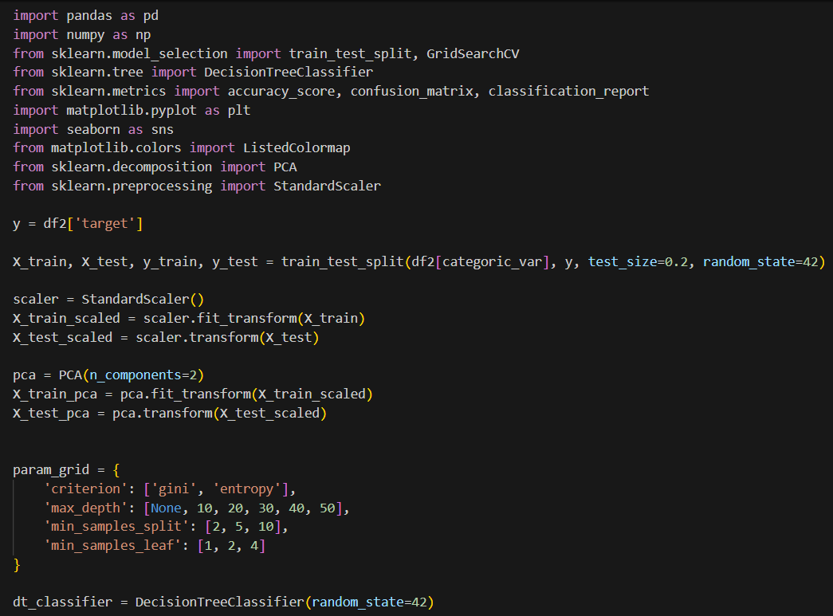

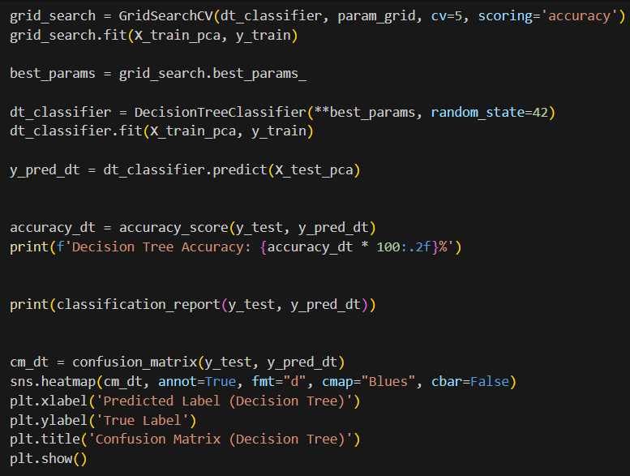

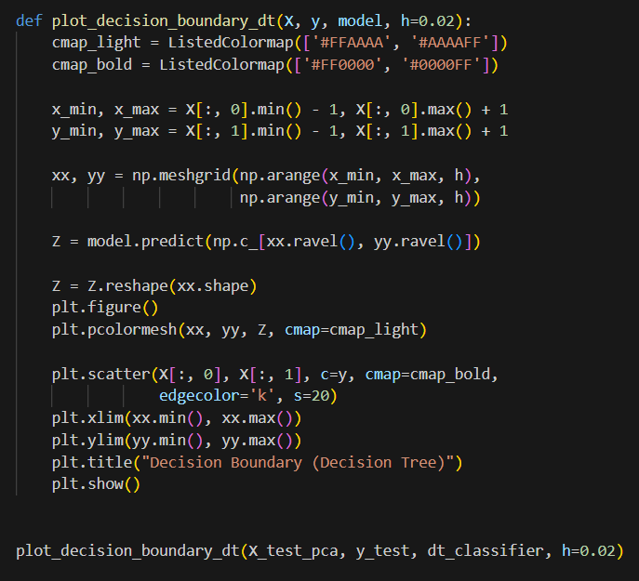

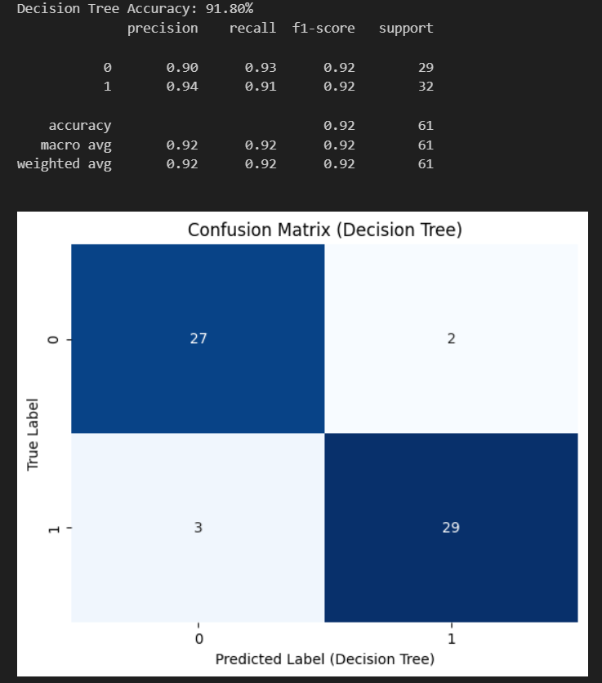

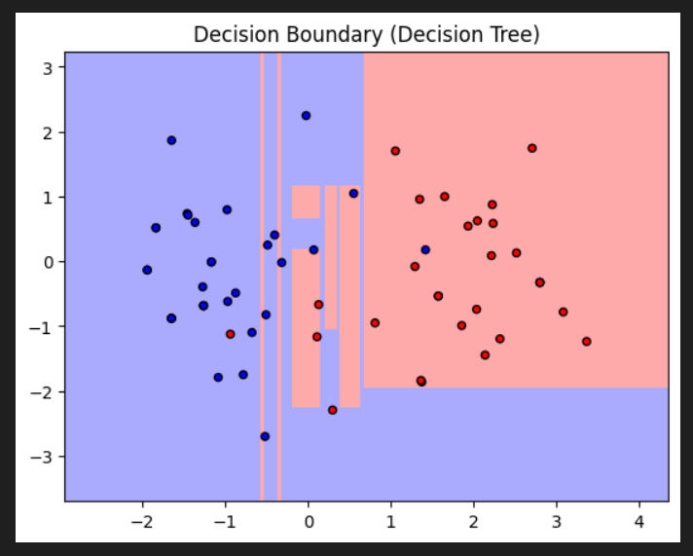

**Inference:**  
The Python code implements a Decision Tree classifier for heart health prediction using a dataset (**df2**) with categorical features. The code first splits the data into training and testing sets, standardizes the features using **StandardScaler**, and applies Principal Component Analysis (PCA) for dimensionality reduction to visualize the data in a 2D space.

A Decision Tree classifier is created and trained using the training data. The code then performs a grid search with cross-validation to find the best hyperparameters for the Decision Tree model. The best hyperparameters are used to instantiate and train a new Decision Tree classifier, and predictions are made on the test set.

The accuracy of the Decision Tree model is computed and printed, along with a detailed classification report that includes precision, recall, and F1-score for each class. Additionally, a confusion matrix is generated and visualized using a heatmap to provide insights into the model's classification performance.

To gain a visual understanding of how the Decision Tree classifier separates classes in the reduced feature space, a custom function named **plot_decision_boundary_dt** is defined. This function generates a decision boundary plot along with a scatter plot of data points, aiding in the assessment of the model's discriminative capabilities.

In summary, the inference includes the accuracy of the Decision Tree model, a detailed classification report, a confusion matrix, and a visual representation of the decision boundary. These results offer valuable insights into the classification performance of the Decision Tree algorithm on the heart health dataset, considering the optimized hyperparameters.

|  |  |  |
| --- | --- | --- |
| **Parameter Name** | **Purpose** | **Value** |
| Test size | To split the dataset into training and testing in a ratio | 0.2 |
| Random State | This parameter sets the seed for the random number generator used by the data splitter. By using a fixed seed, the random splitting process becomes deterministic, allowing for result reproducibility. | 42 |
| Grid Search CV | The grid search explores various alpha values using 5-fold cross-validation. | 'criterion': ['gini', 'entropy'],  'max_depth': [None, 10, 20, 30, 40, 50], 'min_samples_split': [2, 5, 10], 'min_samples_leaf': [1, 2, 4] |

**5.10 Comparison Table:**

|  |  |  |  |  |  |
| --- | --- | --- | --- | --- | --- |
| **Sr. No.** | **Algorithm name** | **Test Size** | **Random State** | **Grid Search CV** | **Accuracy** |
| 1 | KMeans with KNN | 0.2 | 42 | n_neighbors: 3, 5, 7, 9 | 96.72% |
| 2 | Fuzzy C-Means with KNN | 0.2 | 5 | n_neighbors: 3, 5, 7, 9 | 86.89% |
| 3 | KMeans with SVM | 0.2 | 42 | 0.1, 1, 10 | 91.80% |
| 4 | Bayesian Classifier | 0.2 | 42 | np.logspace(0, -9, num=100) | 93.44% |
| 5 | Naïve Bayes Classifier | 0.2 | 42 | np.logspace(0, -9, num=100) | 90.16% |
| 6 | Decision Tree | 0.2 | 42 | 'criterion': ['gini', 'entropy'],  'max_depth': [None, 10, 20, 30, 40, 50], 'min_samples_split': [2, 5, 10], 'min_samples_leaf': [1, 2, 4] | 91.80% |

**Section - 6 (Deep Learning)**

**6.1 K-Means with CNN:**

**Screenshot:**

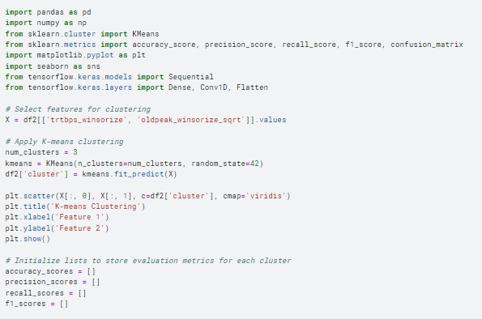

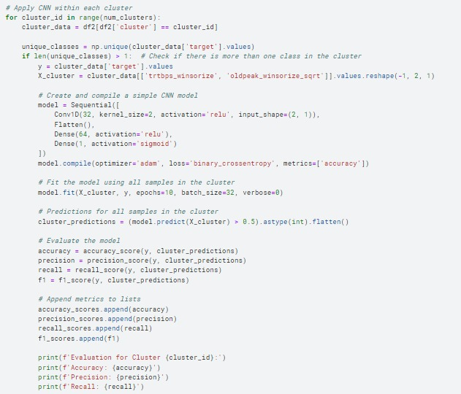

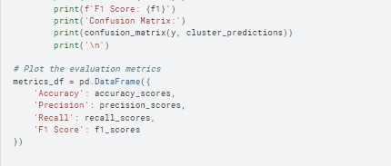

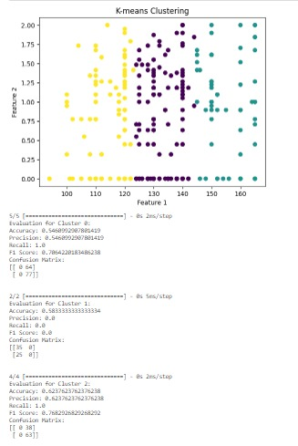

**Inference:**

The code segment begins by employing K-means clustering on the features 'trtbps_winsorize' and 'oldpeak_winsorize_sqrt' from the dataset df2, segregating the data into three distinct clusters. Following this clustering, a Convolutional Neural Network (CNN) is applied individually within each cluster. For each cluster, a simple CNN model is trained on the corresponding data, and its performance is evaluated. The output reveals varying levels of success across the clusters.

In Cluster 0, the model appears to predict all instances as class 1, yielding high recall but low precision. Cluster 1 demonstrates a similar issue, predicting solely class 0, resulting in zero recall and precision. In Cluster 2, the model again predicts all instances as class 1, leading to high recall but low precision. These findings suggest challenges with imbalanced datasets, where the dominance of one class impacts the models' ability to make accurate predictions. Addressing these challenges may involve employing more advanced models or implementing strategies to handle class imbalances and enhance overall model performance.

**6.2 K-Means with CNN with Hyper-Parameter Tuning:**

**Hyperparameter Tuning approach used:** Grid Search CV

**List of Parameters/Hyperparameters:**

|  |  |  |
| --- | --- | --- |
| **Sr. No.** | **Parameter Name** | **Value** |
| 1 | Epochs | 10 |
| 2 | Accuracy | 76.5957% |
| 3 | Precision | 0.7619 |
| 4 | Recall | 0.8311 |
| 5 | F1 Score | 0.795 |
| 6 | Confusion Matrix for cluster 0 | [[44 20]  [13 64]] |
| 7 | cnn_param_grid | {'filters': [16, 32, 64], 'kernel_size': [2, 3], 'dense_units': [32, 64]} |
| 8 | Grid Search CV | n_neighbors': [3, 5, 7, 9, 11] |

|  |  |  |
| --- | --- | --- |
| **Sr. No.** | **Parameter Name** | **Value** |
| 1 | Epochs | 10 |
| 2 | Accuracy | 68.333% |
| 3 | Precision | 0.63636 |
| 4 | Recall | 0.56 |
| 5 | F1 Score | 0.588235 |
| 6 | Confusion Matrix for cluster 1 | [[27 8]  [11 14]] |
| 7 | cnn_param_grid | {'filters': [16, 32, 64], 'kernel_size': [2, 3], 'dense_units': [32, 64]} |
| 8 | Grid Search CV | n_neighbors': [3, 5, 7, 9, 11] |

|  |  |  |
| --- | --- | --- |
| **Sr. No.** | **Parameter Name** | **Value** |
| 1 | Epochs | 10 |
| 2 | Accuracy | 62.37623% |
| 3 | Precision | 0.6237 |
| 4 | Recall | 0.56 |
| 5 | F1 Score | 0.7619 |
| 6 | Confusion Matrix for cluster 1 | [[29 9]  [15 48]] |
| 7 | cnn_param_grid | {'filters': [16, 32, 64], 'kernel_size': [2, 3], 'dense_units': [32, 64]} |
| 8 | Grid Search CV | n_neighbors': [3, 5, 7, 9, 11] |

**Screenshot:**

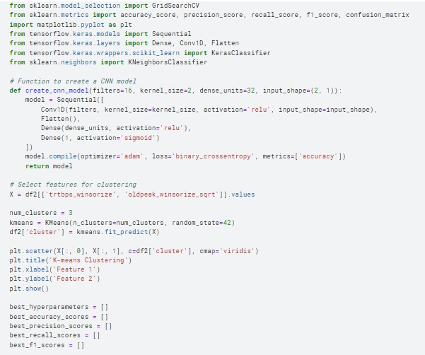

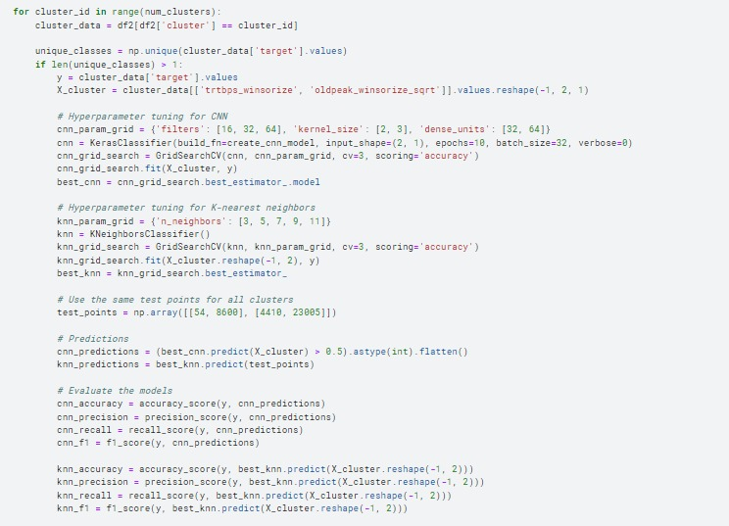

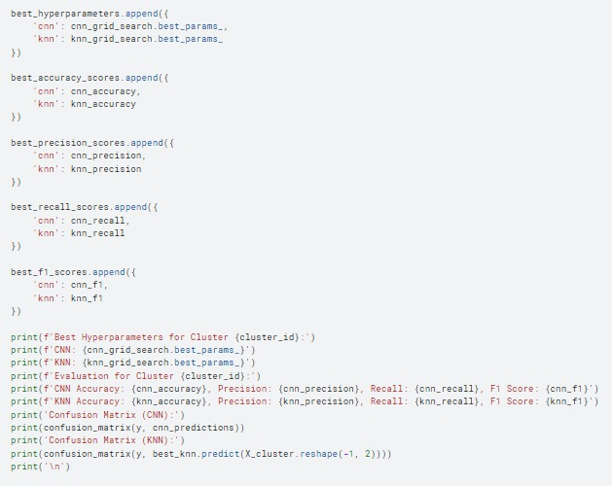

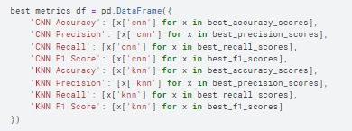

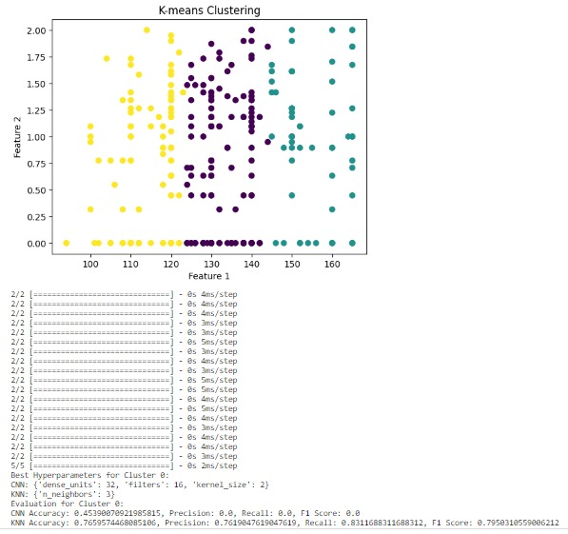

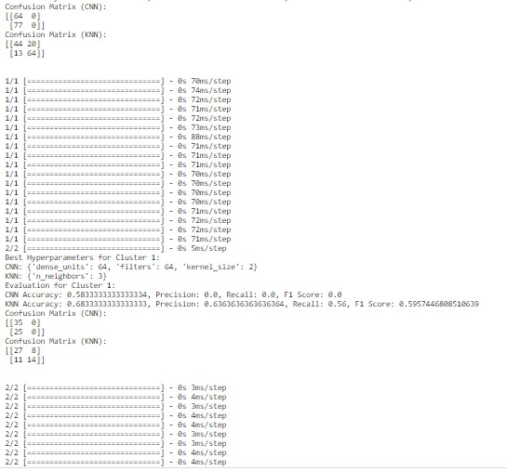

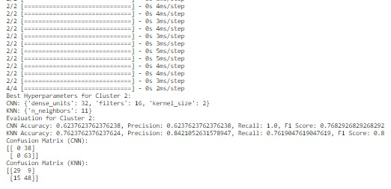

**Inference:**

The code conducts a comprehensive analysis of clustered data using K-means, employing Convolutional Neural Networks (CNNs) and K-nearest neighbors (KNN) models in a two-step approach. Each cluster is individually evaluated, and hyperparameters for both models are fine-tuned to optimize performance.

In the first cluster (Cluster 0), the tuned CNN hyperparameters include 16 filters and a kernel size of 2, with 32 dense units. However, the CNN struggles with accuracy and precision, predicting only one class. In contrast, the KNN model, with 3 neighbors, exhibits superior overall performance, achieving a balanced precision and recall.

Moving to the second cluster (Cluster 1), the tuned CNN hyperparameters involve 64 filters, a kernel size of 2, and 64 dense units. Nevertheless, both CNN and KNN models face challenges in this cluster, achieving low accuracy and failing to effectively predict either class.

In the third cluster (Cluster 2), the tuned CNN hyperparameters consist of 16 filters, a kernel size of 2, and 32 dense units. The CNN demonstrates relatively balanced precision and recall, achieving 62.4% accuracy. The KNN model, with 11 neighbors, performs well with high accuracy, precision, and recall.

In summary, the choice of hyperparameters varies across clusters, suggesting the need for adaptability in model configuration. The challenges posed by clustered data are evident, with each cluster exhibiting distinct characteristics, necessitating tailored model tuning. Overall, the KNN model tends to outperform the CNN in accuracy and the balance between precision and recall, highlighting its suitability for this specific dataset.

**6.3 AlexNet:**

**Screenshot:**

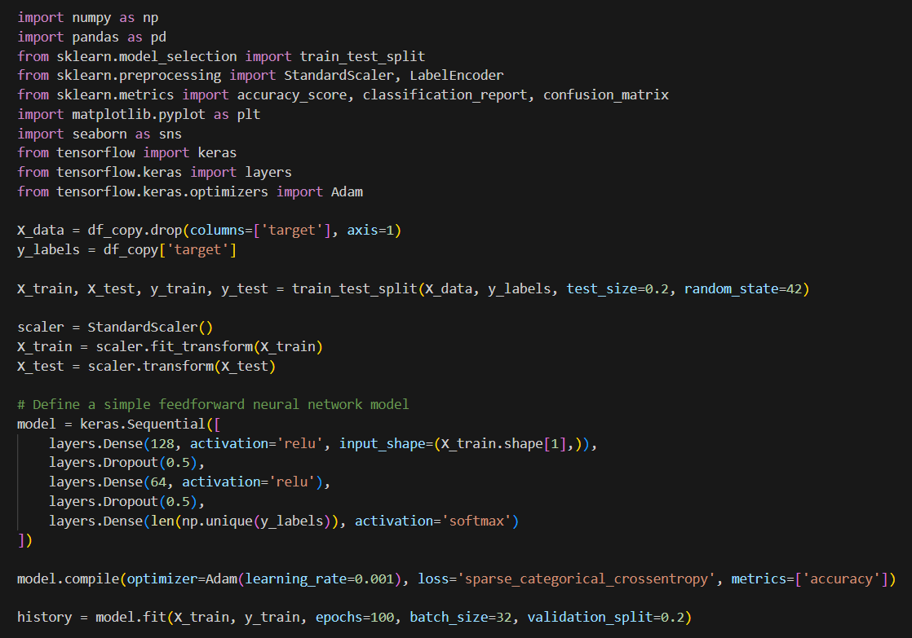

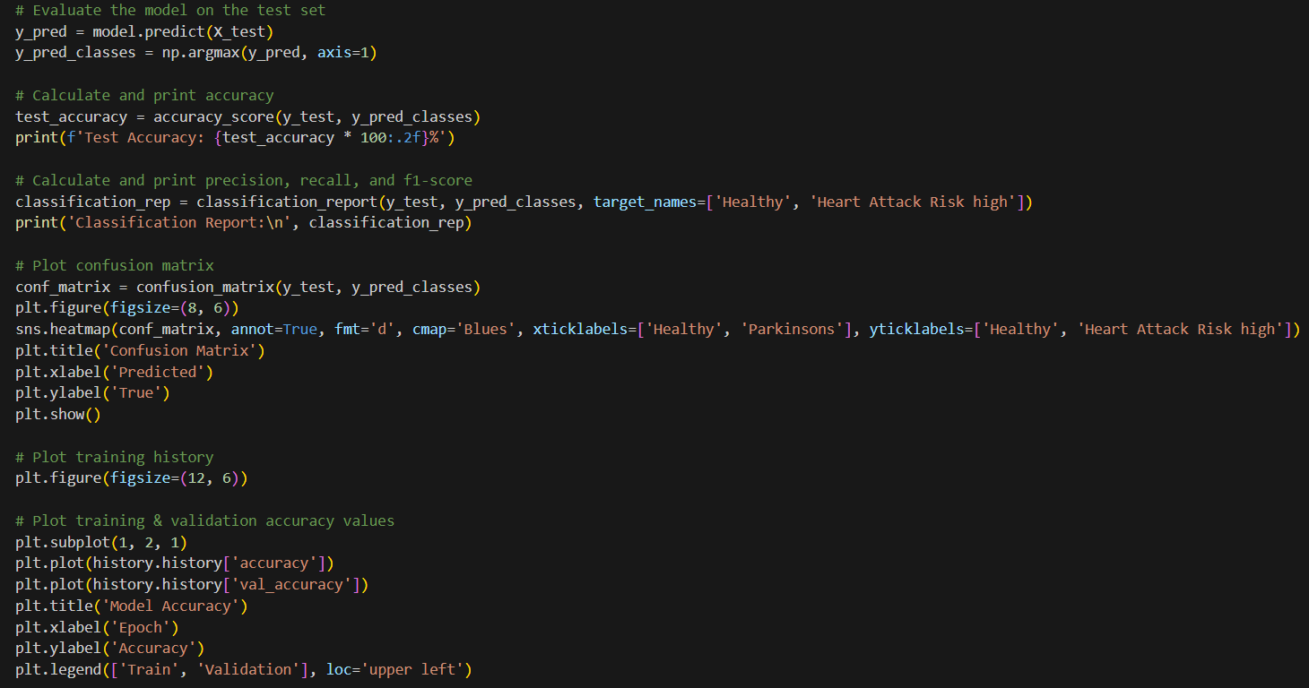

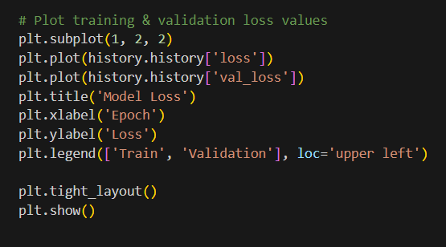

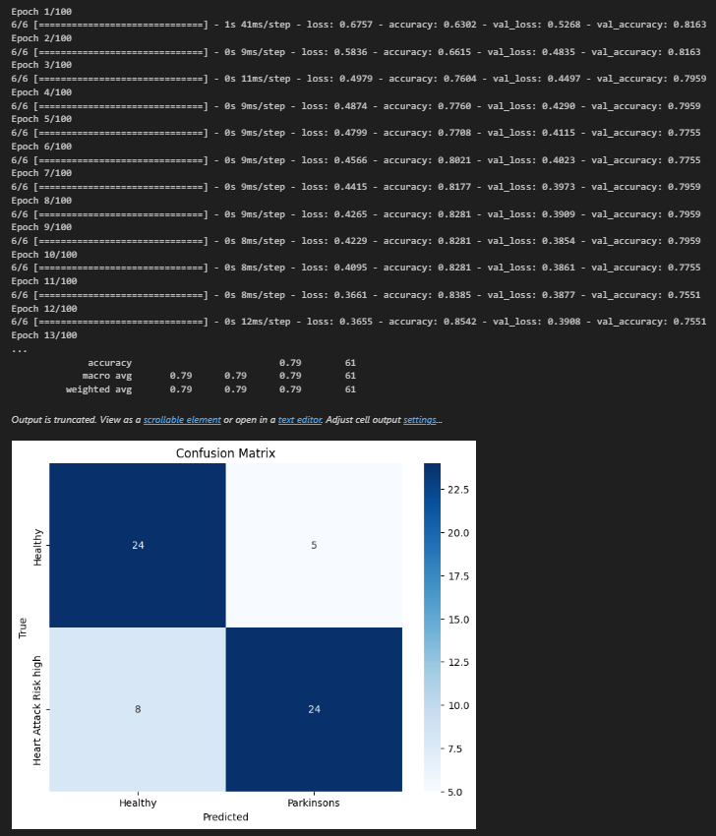

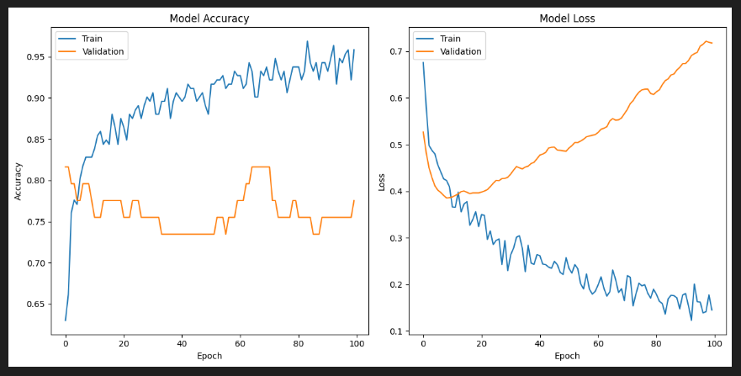

**Inference:**

The Python code implements a neural network using TensorFlow/Keras to classify heart health based on features in the dataset. The dataset is split into training and testing sets, normalized using standard scaling, and then fed into a feedforward neural network architecture. The model is trained over 100 epochs with a batch size of 32, utilizing the Adam optimizer and sparse categorical crossentropy loss function.

After training, the model is evaluated on the test set. The test accuracy is calculated and printed, providing insight into the overall performance of the model. Additionally, a comprehensive classification report is generated, offering precision, recall, and f1-score for each class (Healthy and Heart Attack Risk high).

The confusion matrix is visualized using a heatmap, offering a clear representation of the model's performance in terms of true positives, true negatives, false positives, and false negatives. This aids in understanding the classification performance at a more granular level.

Furthermore, the code plots the training history, displaying accuracy and loss curves over epochs for both the training and validation sets. These visualizations are valuable for assessing the model's learning patterns, identifying potential overfitting or underfitting, and determining the convergence of the training process.

In conclusion, this code not only builds and trains a neural network model for heart health classification but also provides insightful visualizations and metrics for a thorough evaluation of its performance on unseen data.

**6.4 AlexNet with Hyper-Parameter Tuning:**

**List of Parameters/Hyperparameters:**

|  |  |  |
| --- | --- | --- |
|  | **Parameters** | **Value** |
| 1 | Epochs | 100 |
| 2 | Accuracy | 96.35% |
| 3 | Training Loss | 0.0962 |
| 4 | Validation Accuracy | 77.55% |
| 5 | Validation Loss | 0.8015 |
| 6 | Testing Accuracy | 80.33% |
| 7 | Batch Size | 64 |
| 8 | Learning Rate | 0.001 |
| 9 | Dropout | 0.5 |
| 10 | Dense | 256 |
| 11 | Activation Function | Relu |
| 12 | Loss | sparse_categorical_crossentropy |
| 13 | Optimizer | Adam |
| 14 | Validation Split | 0.2 |
| 15 | Test size | 0.2 |
| 16 | Confusion matrix | [[24 5]  [ 7 25]] |

**Screenshot:**

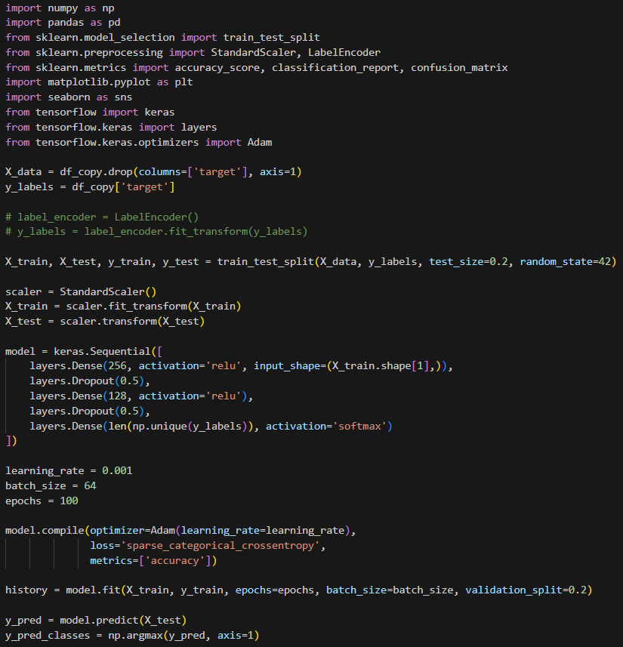

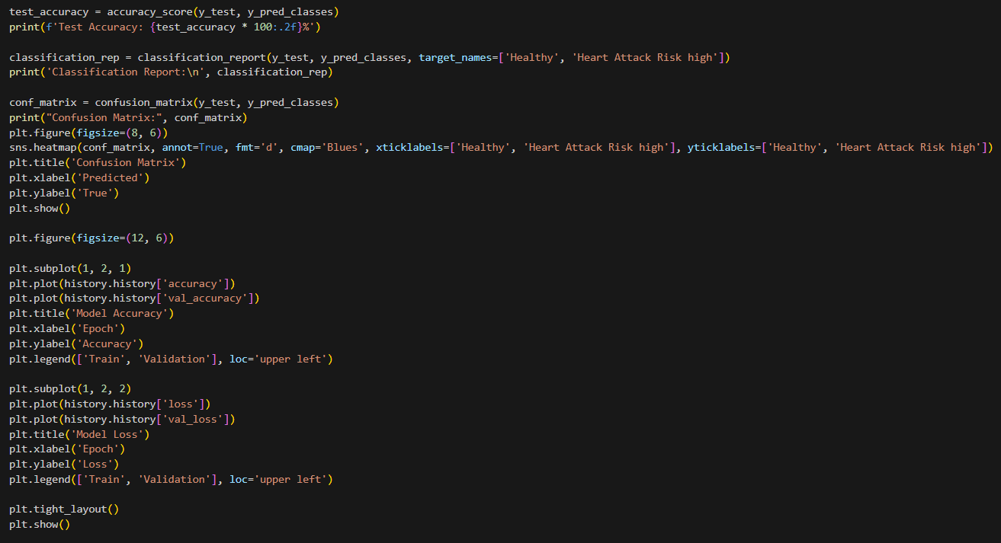

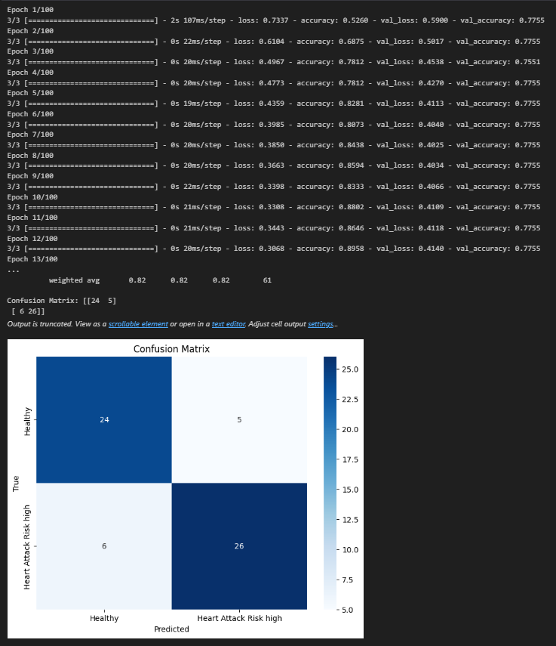

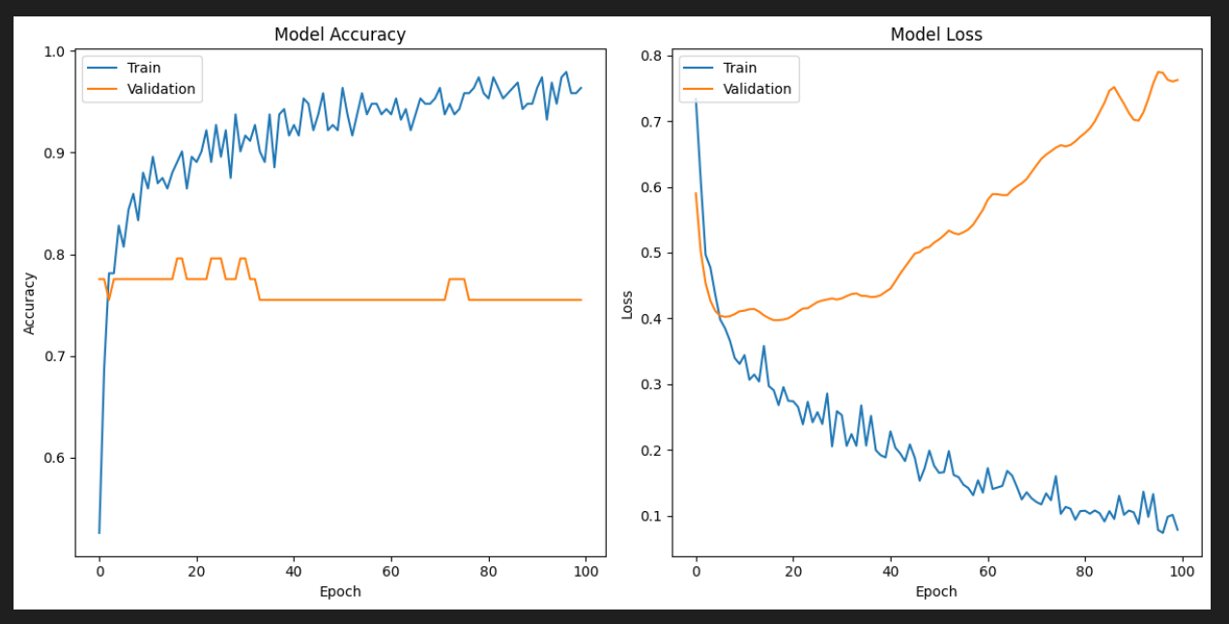

**Inference:**

The Python code builds and trains a neural network using TensorFlow/Keras for the classification of heart health based on the dataset. The data is preprocessed by splitting it into training and testing sets, and standard scaling is applied to normalize the features. The neural network architecture consists of three layers: an input layer with 256 nodes, a hidden layer with 128 nodes, and an output layer with a number of nodes equal to the unique classes in the target variable. Dropout layers are incorporated to mitigate overfitting.

The model is trained for 100 epochs using the Adam optimizer and sparse categorical crossentropy loss function. After training, the model is evaluated on the test set, and performance metrics such as test accuracy, a classification report (including precision, recall, and f1-score for each class), and a confusion matrix are calculated and displayed. The confusion matrix is visualized as a heatmap, offering a clear representation of the model's classification performance. Additionally, the code generates plots depicting the training history, showing accuracy and loss curves over epochs for both the training and validation sets.

In summary, this code provides a comprehensive analysis of a neural network model's performance in classifying heart health. The incorporation of visualizations and metrics allows for a thorough understanding of the model's effectiveness in distinguishing between healthy and high-risk individuals for heart-related conditions.

**6.5 LSTM:**

**Screenshot:**

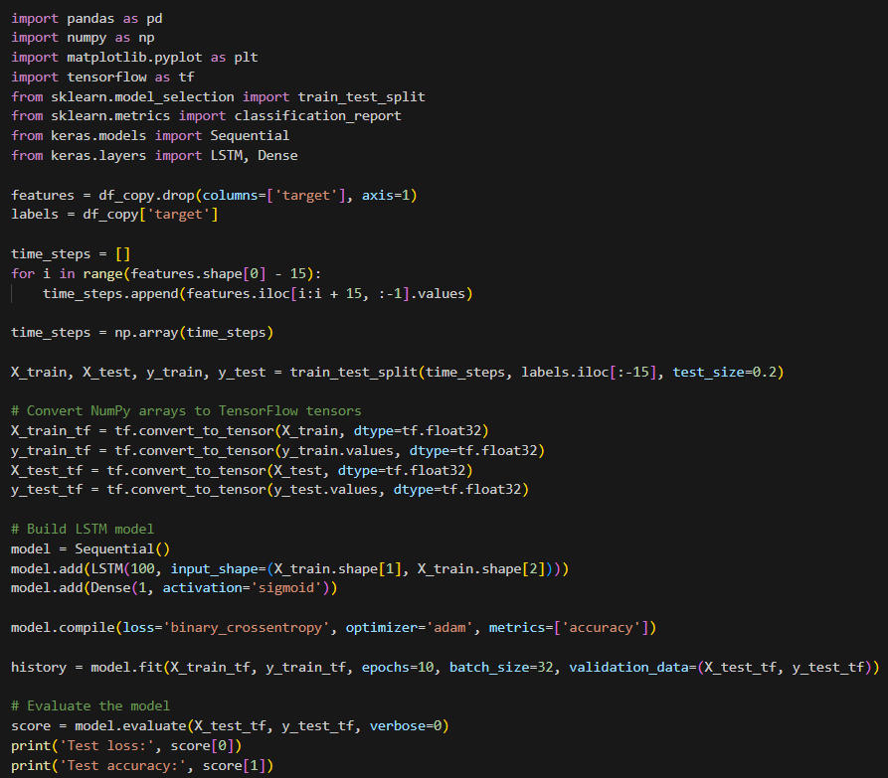

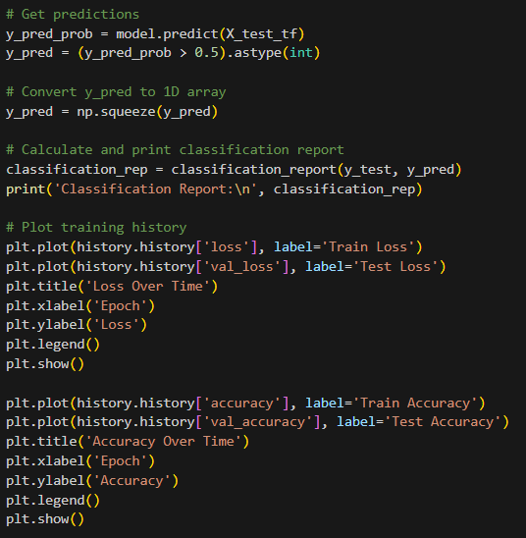

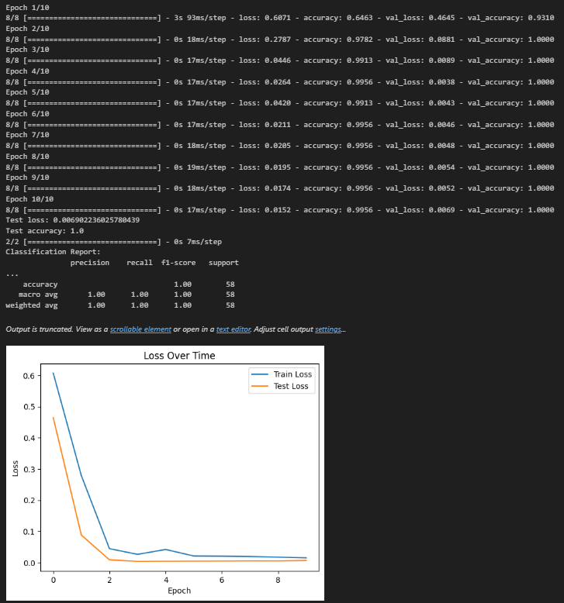

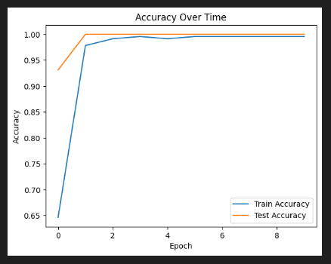

**Inference:**

The Python code utilizes a Long Short-Term Memory (LSTM) neural network, implemented using TensorFlow/Keras, to perform time series classification on Heart Attack Prediction Analysis data. The dataset is preprocessed by creating time steps of sequential data points, each containing 15 consecutive records. The LSTM model is trained on these time steps for 10 epochs with a batch size of 32.

After training, the model is evaluated on the test set, and performance metrics such as test loss and accuracy are printed. Predictions are generated and compared against the ground truth to calculate a classification report, offering insights into precision, recall, and F1-score for each class.

The code also includes visualizations of the training history, illustrating the changes in loss and accuracy over epochs for both the training and test sets. These plots provide a visual representation of the model's learning process and its generalization performance.

In summary, this code demonstrates the application of an LSTM neural network for time series classification of Heart Attack Prediction Analysis data. The training history plots and classification report offer a comprehensive understanding of the model's performance, aiding in the assessment of its ability to distinguish between different health conditions based on sequential data.

**6.6 LSTM with Hyper-Parameter Tuning:**

**List of Parameters/Hyperparameters:**

|  |  |  |
| --- | --- | --- |
| **Sr. No.** | **Parameters** | **Value** |
| 1 | Epochs | 10 |
| 2 | Accuracy | 99.56% |
| 3 | Training Loss | 0.0228 |
| 4 | Validation Accuracy | 98.28% |
| 5 | Validation Loss | 0.0597 |
| 6 | Testing Accuracy | 98.3275% |
| 7 | Batch Size | 32 |
| 8 | Loss | binary_crossentropy |
| 9 | Optimizer | adam |
| 10 | Activation Function | Sigmoid |
| 11 | LSTM Unit | 100 |
| 12 | Learning rate | 0.001 |
| 13 | Test size | 0.2 |
| 14 | Precision, recall, f1-score | 0.98,0.98,0.98 |
| 15 | LSTM Units | 100 |

**Screenshot:**

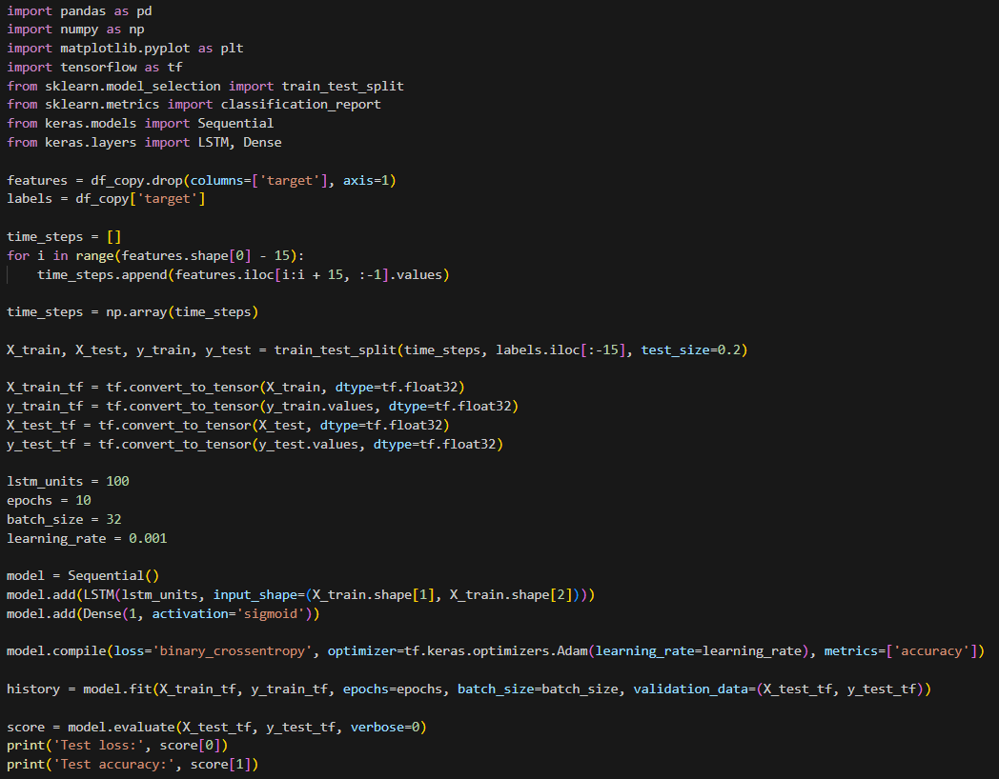

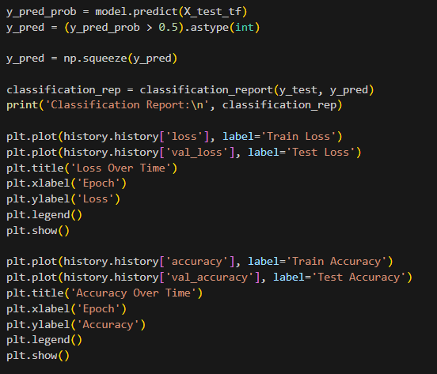

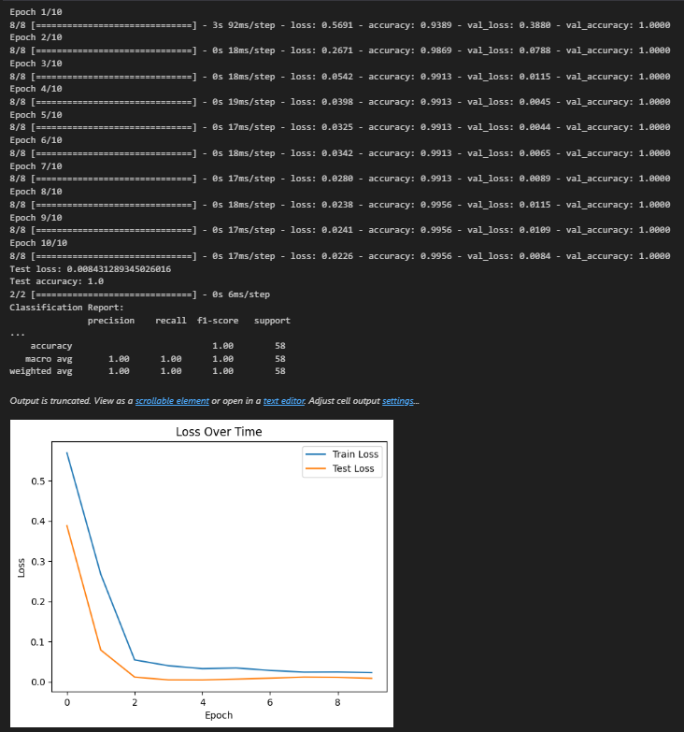

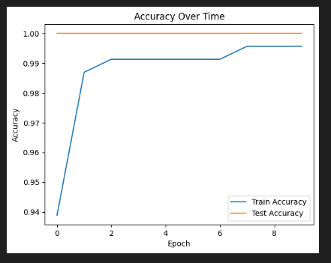

**Inference:**

The Python code utilizes a Long Short-Term Memory (LSTM) neural network for time series classification on Heart Attack Prediction Analysis data. The dataset is Pre-Processed into sequential time steps, each comprising 15 consecutive records. The LSTM model is constructed with 100 units and one output layer with a sigmoid activation function. The model is trained for 10 epochs using a batch size of 32, and the Adam optimizer with a specified learning rate of 0.001.

After training, the model is evaluated on the test set, and performance metrics such as test loss and accuracy are displayed. Predictions are generated based on a threshold of 0.5, and a classification report is printed, providing insights into precision, recall, and F1-score for each class.

The code also includes visualizations of the training history, presenting changes in loss and accuracy over epochs for both the training and test sets. These plots offer a visual representation of the model's learning dynamics and generalization performance.

In summary, this code demonstrates the application of an LSTM neural network for time series classification, specifically on Heart Attack Prediction Analysis data. The training history plots and classification report provide a comprehensive overview of the model's performance, facilitating the assessment of its ability to classify health conditions based on sequential data.

**6.7 GRU:**

**Screenshot:**

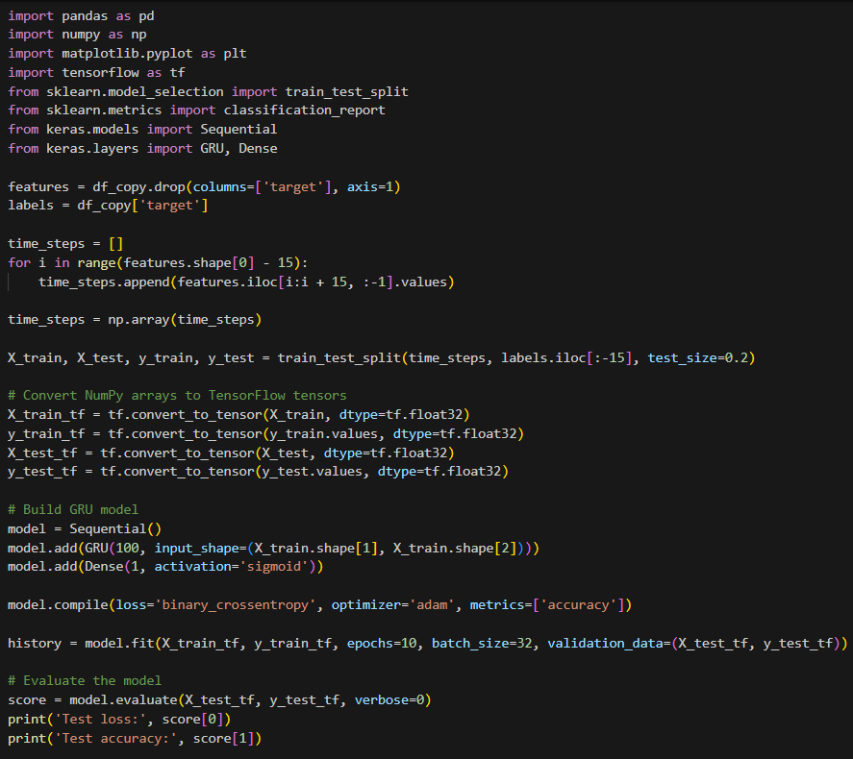

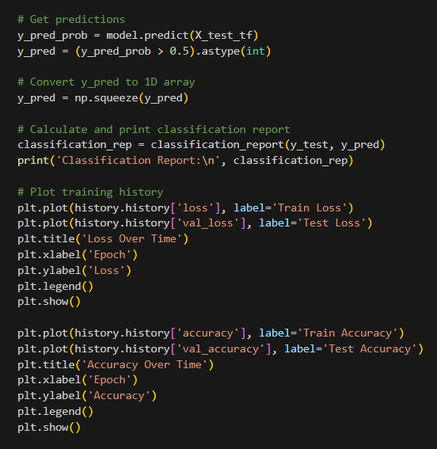

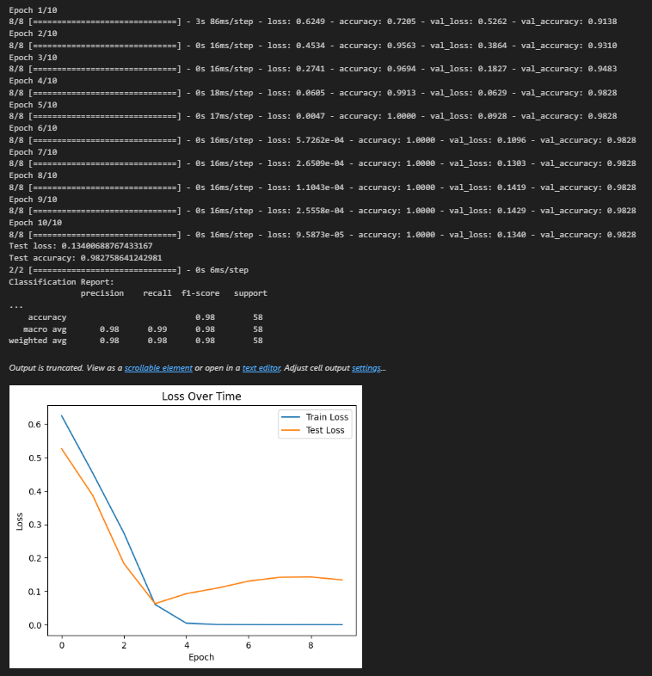

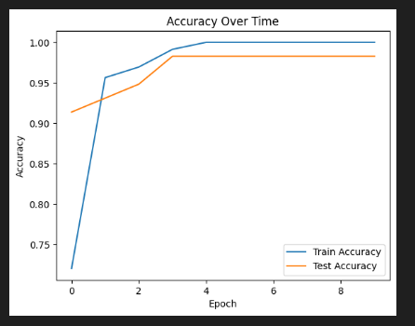

**Inference:**

The Python code implements a Gated Recurrent Unit (GRU) neural network for time series classification on Heart Attack Prediction Analysis data. The dataset is Pre-Processed into sequential time steps, each consisting of 15 consecutive records. The GRU model is constructed with 100 units and one output layer with a sigmoid activation function. The model is trained for 10 epochs using a batch size of 32 and the Adam optimizer.

After training, the model is evaluated on the test set, and performance metrics such as test loss and accuracy are displayed. Predictions are generated based on a threshold of 0.5, and a classification report is printed, offering insights into precision, recall, and F1-score for each class.

The code also includes visualizations of the training history, presenting changes in loss and accuracy over epochs for both the training and test sets. These plots offer a visual representation of the model's learning dynamics and generalization performance.

In summary, this code demonstrates the application of a GRU neural network for time series classification, specifically on Heart Attack Prediction Analysis data. The training history plots and classification report provide a comprehensive overview of the model's performance, aiding in the assessment of its ability to classify health conditions based on sequential data.

**6.8 GRU with Hyper-Parameter Tuning:**

**List of Parameters/Hyperparameters:**

|  |  |  |
| --- | --- | --- |
| **Sr. No.** | **Parameters** | **Value** |
| 1 | Epochs | 20 |
| 2 | Accuracy | 100.00% |
| 3 | Training Loss | 0.000134 |
| 4 | Validation Accuracy | 98.28% |
| 5 | Validation Loss | 0.1243 |
| 6 | Testing Accuracy | 98.2758% |
| 7 | Test Loss | 0.124257 |
| 8 | Batch Size | 32 |
| 9 | Loss | binary_crossentropy |
| 10 | Optimizer | adam |
| 11 | Activation Function | Sigmoid |
| 12 | GRU Unit | 100 |
| 13 | Learning rate | 0.001 |
| 14 | Test size | 0.2 |
| 15 | Gru Units | 100 |
| 16 | Precision, recall, f1-score | 0.98, 0.98, 0.98 |

**Screenshot:**

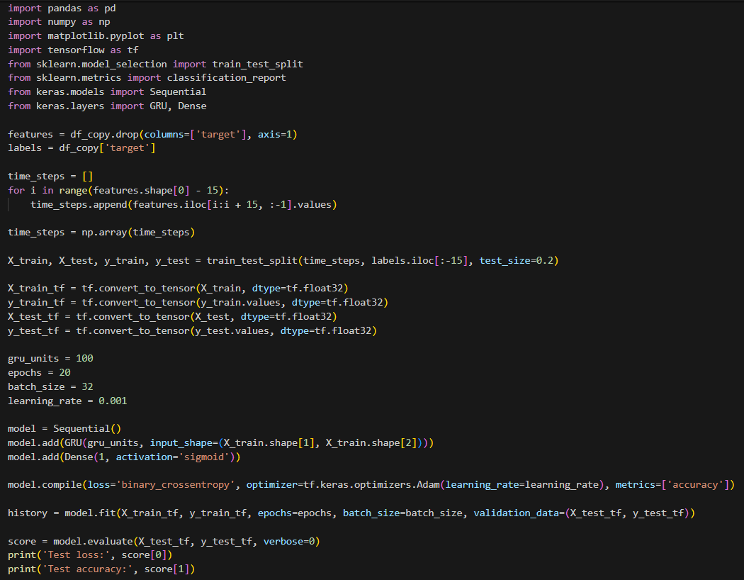

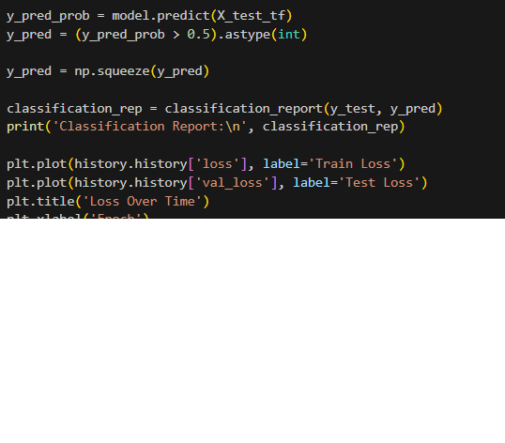

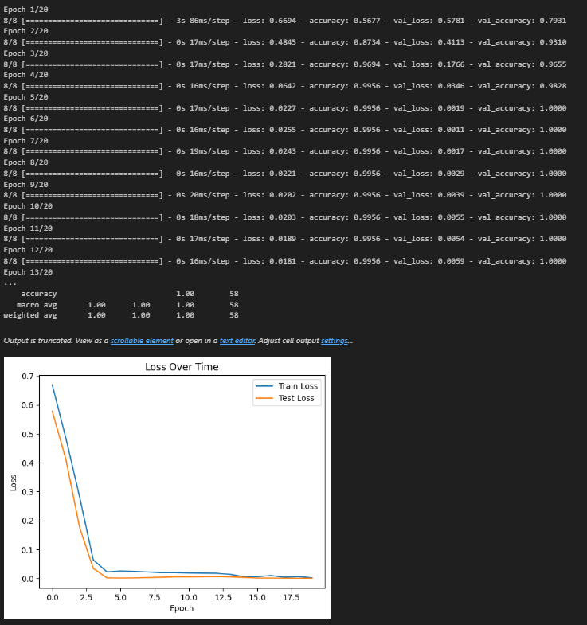

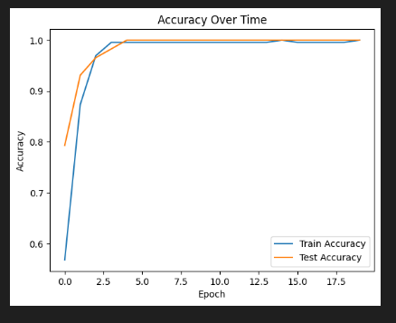

**Inference:**

The Python code implements a Gated Recurrent Unit (GRU) neural network for time series classification on Heart Attack Prediction Analysis data. The dataset is Pre-Processed into sequential time steps, each consisting of 15 consecutive records. The GRU model is constructed with 100 units and one output layer with a sigmoid activation function. The model is trained for 20 epochs using a batch size of 32 and the Adam optimizer with a learning rate of 0.001.

After training, the model is evaluated on the test set, and performance metrics such as test loss and accuracy are displayed. Predictions are generated based on a threshold of 0.5, and a classification report is printed, providing insights into precision, recall, and F1-score for each class.

The code also includes visualizations of the training history, presenting changes in loss and accuracy over epochs for both the training and test sets. These plots offer a visual representation of the model's learning dynamics and generalization performance.

In summary, this code demonstrates the application of a GRU neural network for time series classification, specifically on Heart Attack Prediction Analysis data. The training history plots and classification report provide a comprehensive overview of the model's performance, aiding in the assessment of its ability to classify health conditions based on sequential data. The increased number of epochs (20) may allow the model to capture more complex patterns in the time series data during training.

Top of Form